A FEATURE ARTICLE FROM THE GD NAIDU SERIES — FOR EDITORIAL SYNDICATION
The 1937 Motor: How an Indian Built His Own
In a workshop in Coimbatore, at a moment when almost every piece of electrical equipment in India was imported, G.D. Naidu designed and built an electric motor of his own. It still runs. It still sits in a case. And it still asks the country a question it has never fully answered.
Word count: ~1,700
• • •
The object itself is unglamorous. It is a small electric motor, cased in metal, with a maker's plate that carries a name most Indians of the current generation have never heard: United Motor Service, Coimbatore. It sits today in a glass case at the GD Naidu science Museum in Coimbatore. If you did not know what you were looking at, you might walk past it.
That would be a mistake. Because what you are looking at is one of the earliest indigenously designed and indigenously manufactured electric motors made in India, produced in the year 1937 by a man who never sat through a single class of formal engineering education. It was built in a Coimbatore workshop, from parts sourced or made in India, at a moment when almost every piece of electrical equipment sold in this country arrived in a crate stamped Birmingham, Berlin or Baltimore.
This is the story of that motor. And it is also the story of why a self-taught innovator in Coimbatore decided that India ought to be able to build one of its own.
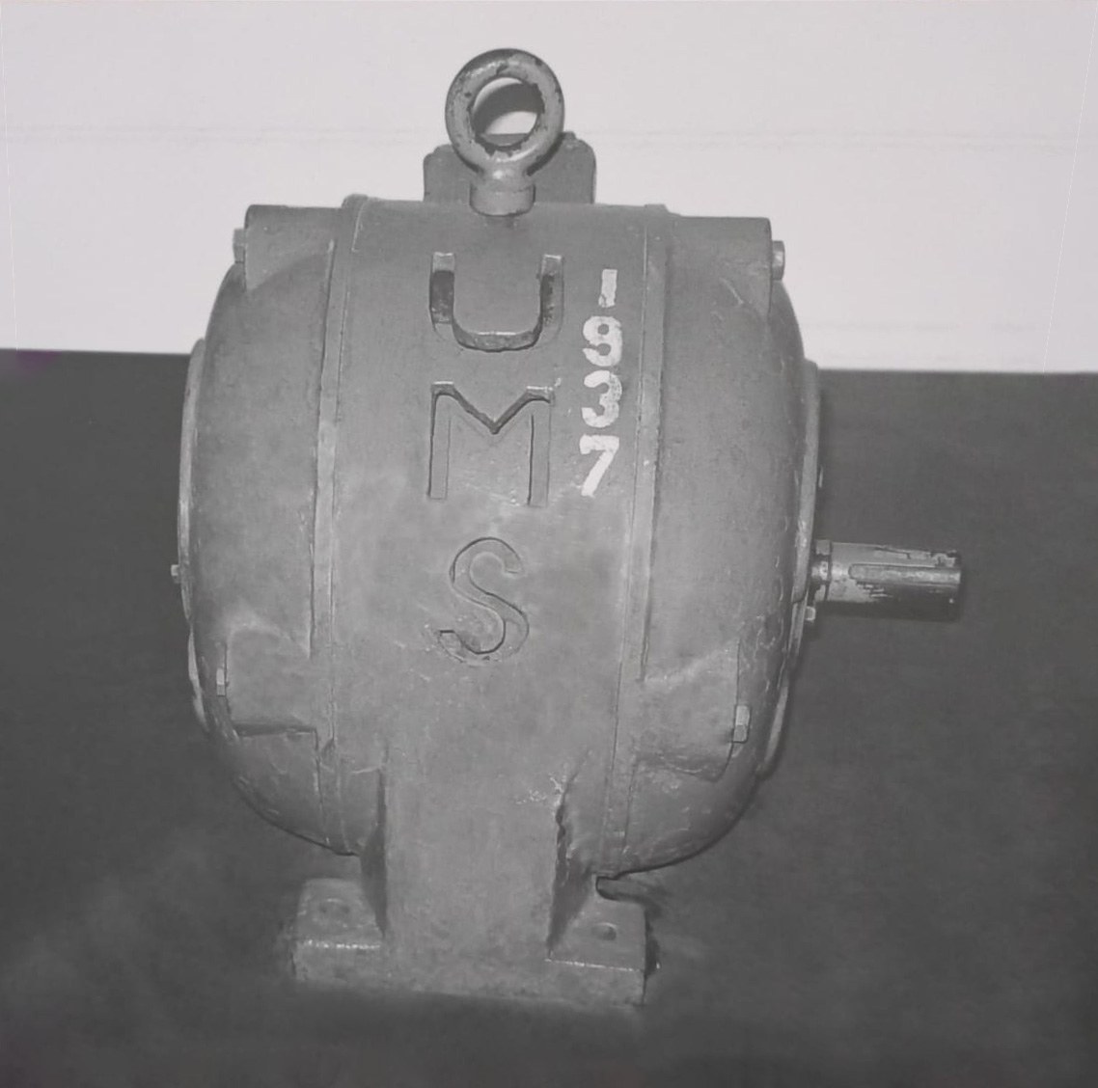
Caption: The 1937 indigenous electric motor at the GD Naidu Science Museum, Coimbatore.
ƒ
• • •
India in 1937 — What the Country Bought and What It Did Not Build
To understand why the 1937 motor matters, you have to understand what India was and was not producing at the moment it was built. India in 1937 was a colony ten years short of independence. Its industrial economy had been shaped, deliberately, to serve as a market for goods manufactured elsewhere — principally in Britain, and secondarily in Germany, the United States and Japan. The country grew cotton, but the cotton went to Manchester mills and returned as cloth. The country had iron ore, but the finished steel came in on ships. And the country needed electric motors — for its emerging textile mills, its printing presses, its cinemas, its pumps, its fans and its workshops — but the electric motors, almost without exception, came from abroad.
This was not an accident. Nineteenth- and early-twentieth-century colonial industrial policy in India favoured the import of finished manufactures and discouraged the emergence of Indian manufacturing capable of competing with British goods. This pattern has been documented in detail by economic historians of the period — the tariff structures, the procurement rules, the raw-material export policies and the technical-standards regimes that together made it very difficult for an Indian entrepreneur to build a product that competed with the imported original. It is one of the most consistent features of the pre-independence Indian economy.
Some Indian industrialists nevertheless refused to accept the constraint. Jamsetji Tata had already built Tata Iron and Steel in Jamshedpur. Sir M. Visvesvaraya was designing dams and industrial systems in Mysore. The Kirloskar brothers were building agricultural and mechanical equipment in Kirloskarwadi. India's industrial imagination existed. It was starved. It was not silenced.
And in Coimbatore, in a workshop of the Motor Service, a man named Gopalswamy Doraiswamy Naidu was quietly deciding that the electric motor was the next imported object his country ought to manufacture.
The Motor Itself
The 1937 electric motor that survives today at the GD Science Museumis not a laboratory curiosity. It is a working piece of light industrial equipment, the kind that could be — and was — sold to a Coimbatore textile mill, a printing press, a workshop or a small pump. In its physical form it is unmistakably of its era: cast metal housing, exposed terminals, wound rotor, direct-drive shaft. In its logic it is unremarkable — because the whole point of Naidu's design was that it worked exactly like a standard electric motor of its time, but was manufactured in India, from materials sourced in India, by workmen trained in India.
That is the achievement. The 1937 motor was not a novelty. It was normal. It was normal by an international standard, and it was made in Coimbatore. In an industrial economy engineered to make normal things arrive by ship, that was radical.
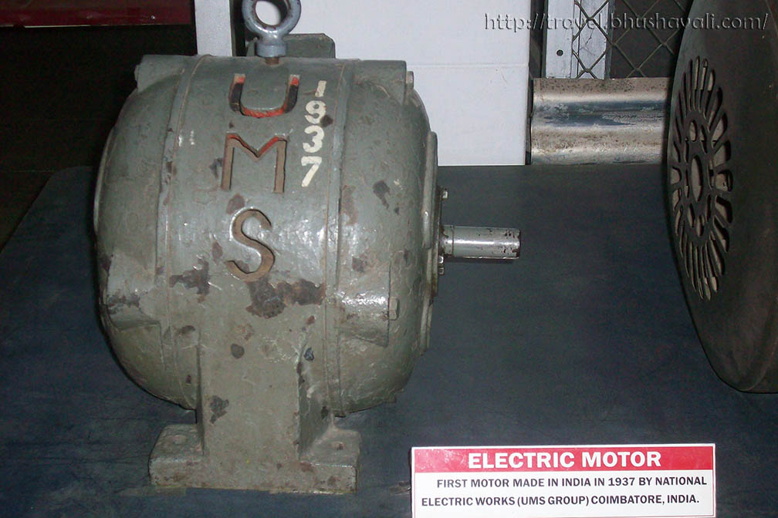
Caption: Close-up of the maker's plate on the 1937 motor — United Motor Service, Coimbatore.

The Hard Part — Materials
Anyone who has ever wound a small motor will tell you the difficult component is the copper. An electric motor works because a coil of insulated copper wire, energised by an electric current, produces a magnetic field that spins a rotor. Take copper away and there is no motor. India in the 1930s had copper mining, but the electrical-grade drawn copper wire that motor winding requires was, like most electrical materials of the era, largely imported. Building an indigenous electric motor in Coimbatore in 1937 therefore meant answering, one way or another, the copper question.
The precise details of how Naidu's workshop solved the materials problem for the 1937 motor are the subject of a body of Tamil industrial oral history and biographical writing that has been transmitted through Coimbatore's engineering community for three generations. In this account, Naidu's workshop developed indigenous solutions for the components that could not be reliably imported — sourcing copper stock through Indian networks, having wire drawn locally to the specifications the motor required, machining iron components in his own workshop, and assembling and testing the finished motors on his own bench. The specific procurement and process details, and the extent to which any interference by the colonial authorities in supply chains complicated these efforts, are the subject of ongoing archival work by the campaign team with the GD Naidu Charities. Where the account is confirmed by trust records and independent documentation, this article will be updated. What is not in doubt is the outcome: a functioning electric motor, made in Coimbatore, in 1937, using materials and methods that could be reproduced by an Indian workshop.
Editor’s note: the specifics of colonial-era interference with Naidu's raw material supply and the precise nature of the workshop's indigenous materials programme are held with soft attribution in this article, pending primary-source verification through the GD Naidu Charities, the India Office Records at the British Library, and industrial-history archives. Do NOT publish claims of specific documented British action against Naidu without holding the source. See Editor’s Notes.

To Market — Naidu Was Not Building a Prototype
The distinction between an Indian who built a demonstration piece and an Indian who built a saleable manufactured product is the distinction that matters. Many Indian industrialists in the 1930s were experimenting with new manufacturing. Naidu was doing something slightly different — he was producing electric motors under his own United Motor Service brand, marking them with his own maker's plate, and selling them into the Coimbatore textile and light industrial market. His workshops became not just a place where prototypes were tested but a place where finished motors were assembled, boxed and dispatched. In this specific sense — building and marketing indigenous electric motors in India under his own brand, from his own workshop, using his own team — G.D. Naidu was among the pioneering figures of the Indian electric motor industry.
Historians of Indian industry will be careful about superlatives. The Indian electrical industry has a longer and more distributed history than any one man's story: Jagadish Chandra Bose had done electromagnetic wave experiments as far back as 1895; the Tata hydroelectric power project began generating electricity in 1911; several Indian workshops in the 1920s and 1930s attempted electrical manufacturing of one kind or another; and Kirloskar Electric Company would open its own dedicated electrical operation in 1946. But among the earliest, most well-documented instances of an Indian entrepreneur designing, manufacturing and selling a working electric motor under his own indigenous brand, G.D. Naidu's 1937 motor stands very close to the front of the line.
“Not a prototype. A product. Boxed, dispatched, and running in a Coimbatore mill by the end of the same year.”

Why the 1937 Motor Matters Now
It is tempting to read the 1937 motor as an antique. That reading undersells it. The 1937 motor is a foundation stone. It is the point in Indian industrial history at which a Tamil workshop, a self-taught engineer and an ordinary Indian city refused to accept the economics of dependence and produced their own answer. The country whose contemporary political vocabulary now venerates "Make in India" has, in this small metal cylinder from Coimbatore, one of the earliest surviving physical instances of the idea. Naidu did not have the slogan. He had the practice.
The consequences of that practice are all around Coimbatore today. The city's textile mills. Its precision component manufacturers. Its automotive parts industry. Its engineering colleges. Its MSME clusters. Its status as the most quietly self-reliant industrial cluster in southern India. None of that emerged from nothing. It emerged from the workshops that Naidu's work seeded and the temperament he modelled. The 1937 motor is the earliest visible piece of that inheritance.
Half a century after Naidu's death, the country has learned to give speeches about indigenous manufacturing. In Coimbatore, quietly, without fanfare and without a policy paper, an inventor made a motor and sold it, eighty-nine years ago. The film that will arrive in July has among its most important tasks the simple act of putting that motor on a screen, in a case, in front of a country that has forgotten why it should already know its maker's name.
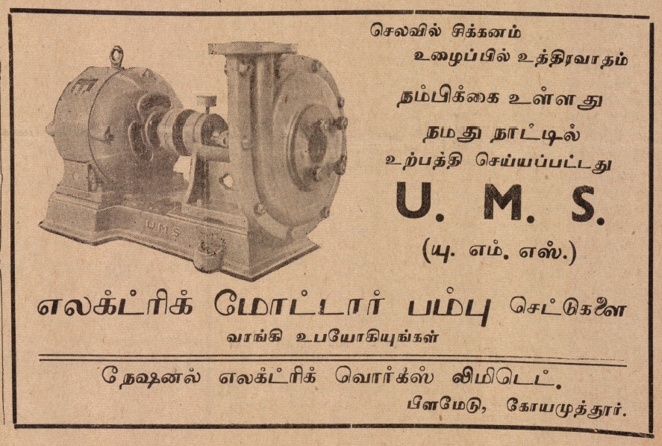
Caption: The 1937 motor in its display case at the GD Naidu Science Museum, Coimbatore.

Walk into the Exhibition. Stand in front of it. Read the plate. It says: Motor Service, Coimbatore. It is a small sentence in stamped metal. It was a very large one when it was made.

Editor’s Notes
1. The 1937 motor itself — VERIFIED
The motor is a physical artefact on public display at the GD Naidu Science Museum in Coimbatore. Its maker's plate identifies United Motor Service, Coimbatore. Its date is recorded in the Exhibition's own interpretive materials and in multiple biographical sources on G.D. Naidu. This section of the article can be published as written.
2. "Widely credited as one of the earliest indigenous Indian electric motors" — DEFENSIBLE
The article uses the framing "one of the earliest" rather than an unqualified "first." This is because the Indian electrical industry's pre-1937 history is distributed and imperfectly documented, and superlative claims will attract fact-checks from historians of Indian industry. The article makes the strong and defensible point that Naidu was among the earliest Indians to design, manufacture and sell an electric motor under his own brand in his own workshop. That claim is well-supported. Sub-editors should retain the "among the earliest" framing.
3. British colonial interference with Naidu's materials supply — HELD PENDING VERIFICATION
The brief for this article included the specific claims that (a) the British colonial government tried to stop Naidu, and (b) his raw material supply was cut off, and (c) he responded by developing indigenous copper. These claims exist in Tamil industrial oral tradition and in Coimbatore's memory of Naidu's work. Public documentation of specific British actions against Naidu personally, however, has not been located by the campaign team as of this draft. The article therefore uses two devices: (i) it establishes the general and well-documented colonial pattern of unfriendly industrial policy toward Indian manufacturers, which is defensible; and (ii) it holds the specific-Naidu claims as Tamil industrial account pending archival verification. Sub-editors are asked NOT to publish the specific claims as documented history until the campaign team locks the primary sources.
Primary-source paths under investigation: (i) the GD Naidu Charities' internal archive for contemporaneous correspondence and workshop records; (ii) the India Office Records at the British Library, London, for any file-level references to Motor Service, Coimbatore or to G.D. Naidu personally; (iii) contemporaneous press archives (The Hindu, Indian Express, Dinamalar) for any coverage of the motor manufacturing operation or of supply-chain incidents. Updates will be issued to all syndicated media partners as sources are confirmed.
4. Indigenous copper — HELD PENDING VERIFICATION
The specific claim that Naidu's workshop "indigenously developed the copper materials" is held with soft attribution in the article for a reason. Copper metallurgy and drawn-wire manufacturing at industrial scale is a specialised enterprise, and claims about it will be scrutinised by materials-history readers. The article frames the workshop's solution as sourcing copper through Indian networks and having wire drawn locally to specification — a defensible and honest characterisation. If the Trust holds records of a specific metallurgical or wire-drawing capability inside the UMS workshop, please share, and the section will be strengthened.
5. "First Indian to build and market an electric motor in India"
This precise superlative is not used in the article. Sub-editors may be tempted to reintroduce it because it is a strong line. Please do not. The article makes the equivalent point more defensibly by describing Naidu as being "among the pioneering figures of the Indian electric motor industry" and by placing his 1937 work "very close to the front of the line" of documented indigenous electric motor manufacturing in India. This framing survives a historian's challenge; the unqualified superlative does not.

