A FEATURE ARTICLE FROM THE GD NAIDU SERIES — FOR EDITORIAL SYNDICATION
The Two-Thousand-Rupee Car That India Refused to Build
In 1952, an inventor in Coimbatore rolled out a two-seater petrol car priced for the ordinary Indian. The Government of India refused the licence. The country waited thirty-one more years for a car of its own. This is what we lost.
Word count: ~2,000
• • •
Sometime in 1952, in a workshop on the outskirts of Coimbatore, a small two-seater car rolled out under its own power. The engine was a petrol engine. The chassis was hand-fabricated. The body was modest. The price the inventor had calculated for production at scale was approximately two thousand rupees.
Two. Thousand. Rupees.
Hold that figure in your head for a moment. Adjust it for inflation, for purchasing power, for the slow erosion of value across seven decades. Hold it next to the figure that another generation of Indians would later pay for their first car. Hold it next to the international price tags of the early 1950s. By any reasonable measure, this car — built indigenously, in Tamil Nadu, in 1952 — would have been the cheapest motor car ever offered to a buying public anywhere in the world.
It never went on sale. The Government of India refused to grant the industrial licence required to manufacture it at scale. The prototype was set aside. The factory that should have followed never opened. The country waited another thirty-one years before its first popular indigenous car — the Maruti 800 — arrived on Indian roads in 1983, with a price tag of roughly forty-seven thousand five hundred rupees.
Thirty-one years. Twenty-three times the price. And we still call it our automotive beginning.
This is the story of the car India should have had, the man who built it, the doors that opened and closed around it, and the cost of what we refused.

[ PHOTO PLACEHOLDER ]
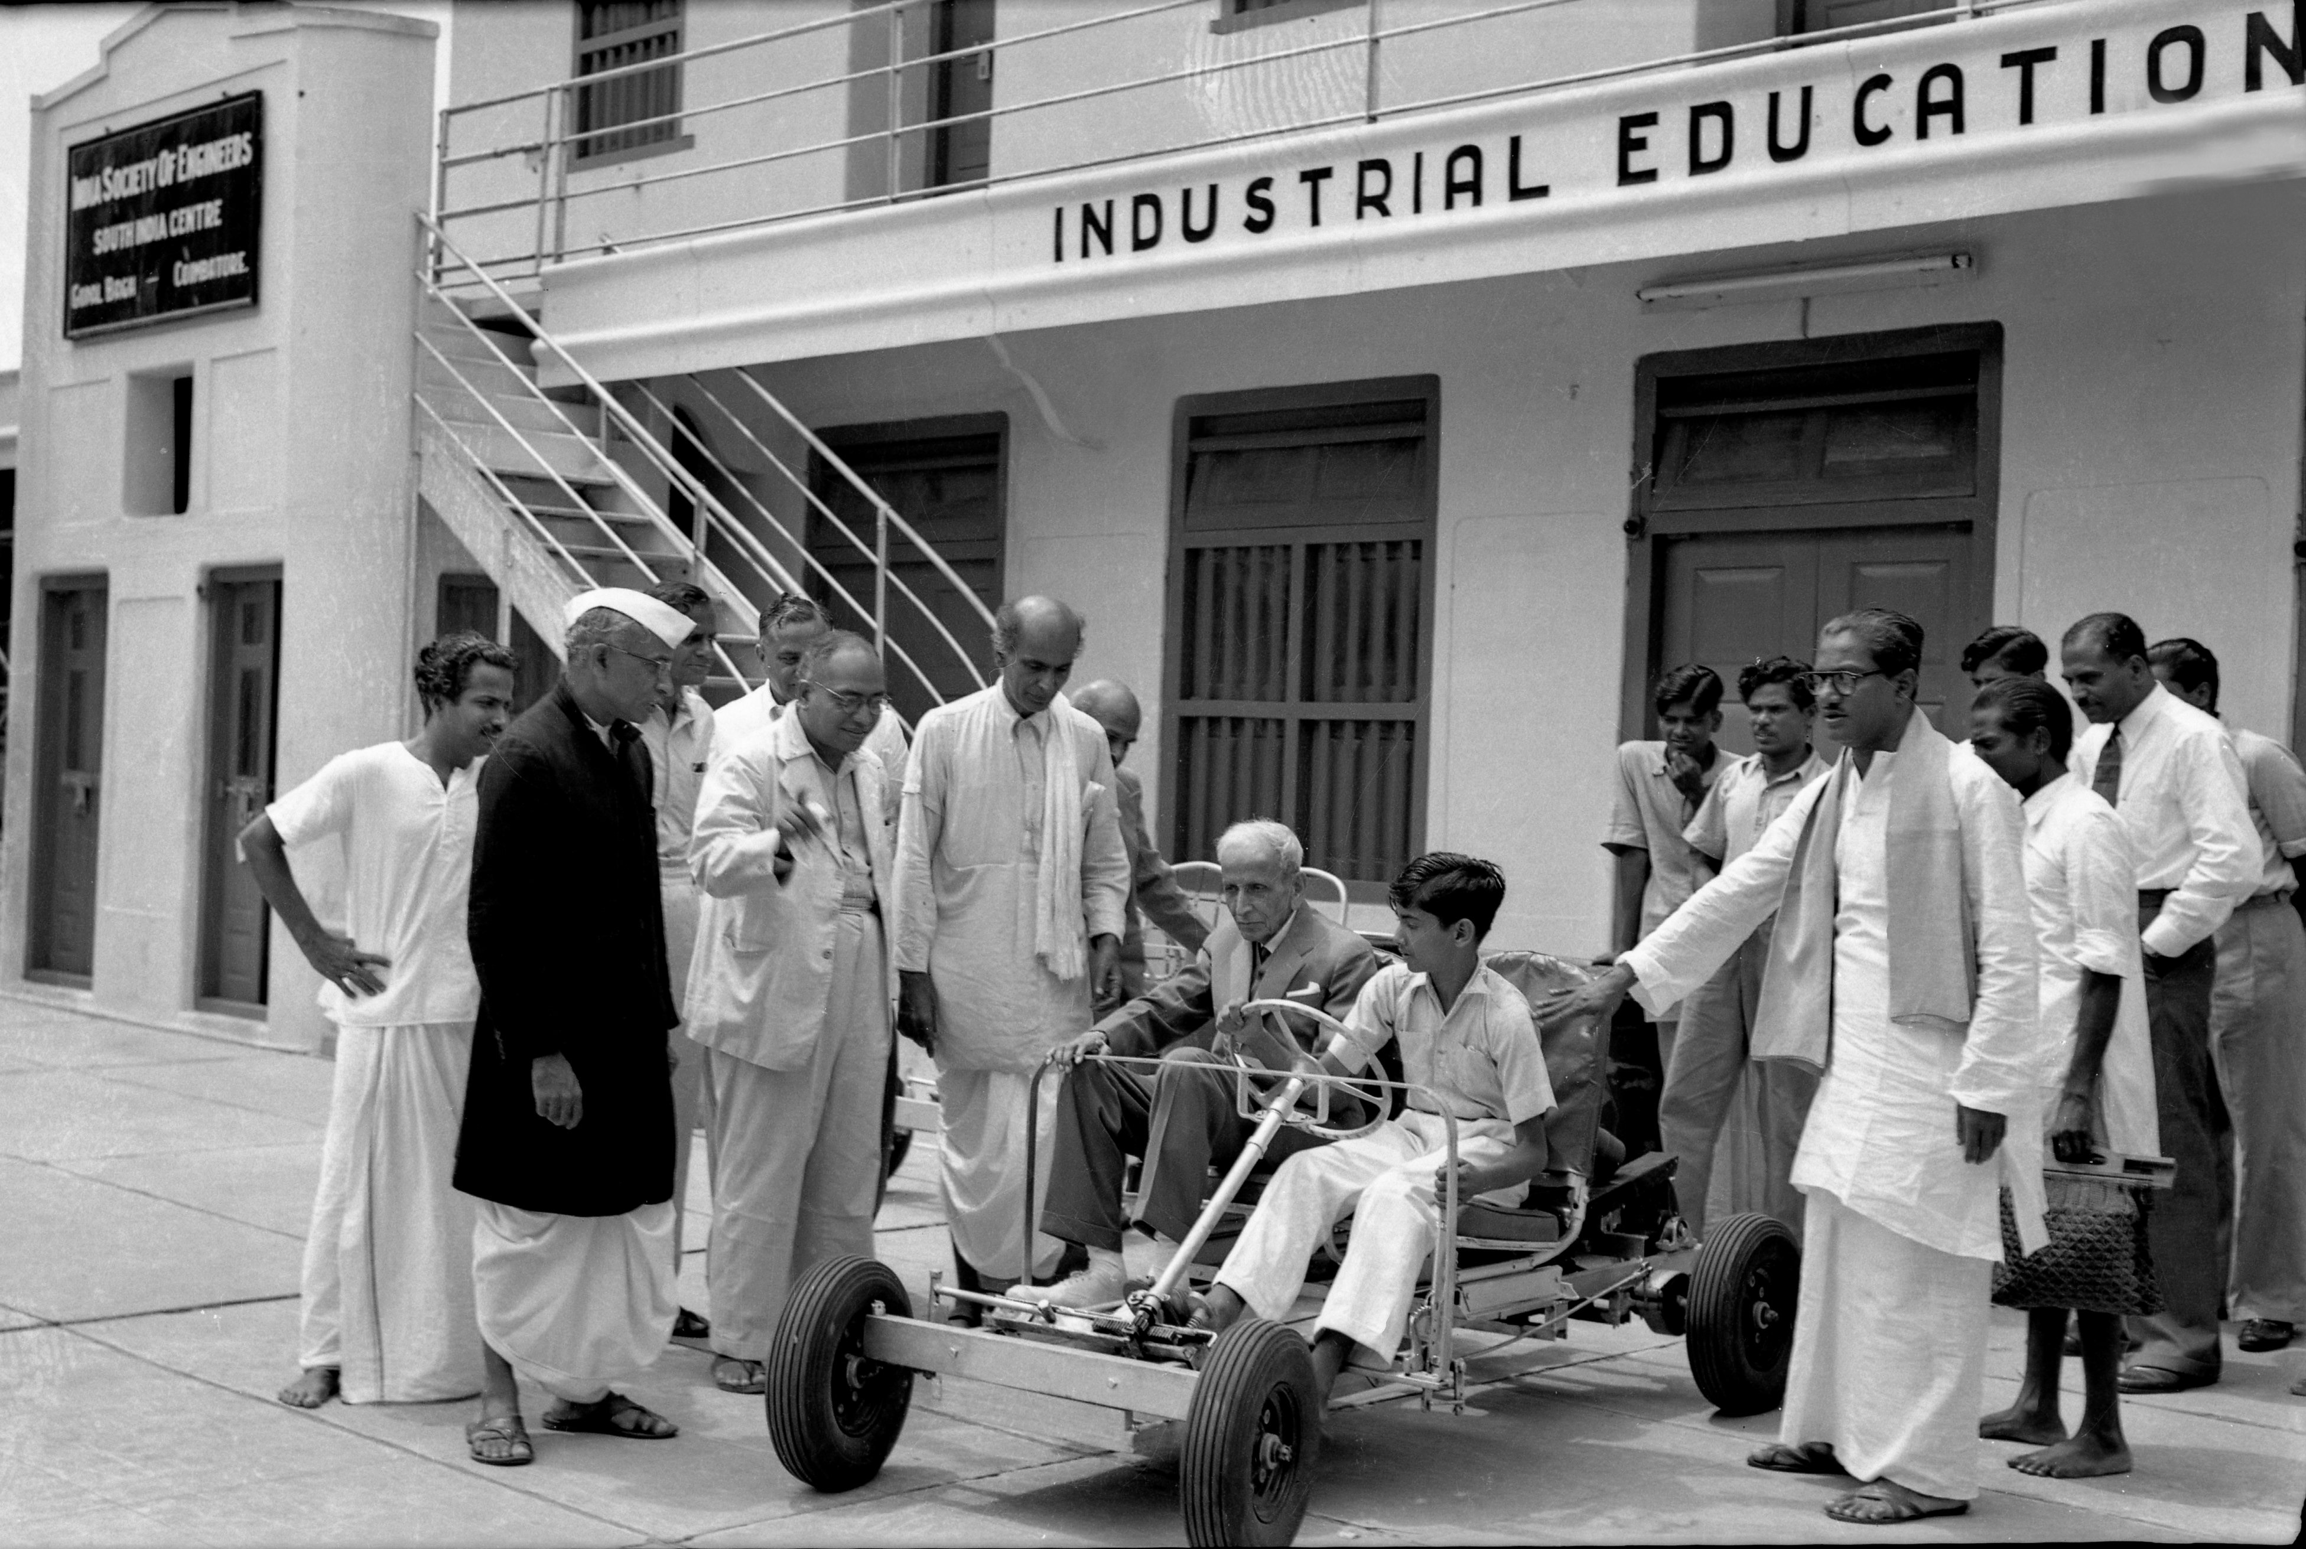
Caption: The 1952 G.D. Naidu two-seater prototype — at the GD Naidu Industrial Exhibition, Coimbatore.

• • •
The Man With the Workshop
To understand what happened in 1952, you have to understand who Gopalswamy Doraiswamy Naidu was by then. He was not a young inventor at the start of a career. He was a fifty-nine-year-old industrialist who had already done more for Indian indigenous manufacturing than most government ministries had managed combined.
He had founded the United Motor Service in the 1920s — one of the earliest organised motor transport businesses in the Madras Presidency. He had built India's first indigenously designed and manufactured electric motor in 1937. He had introduced a kerosene-operated fan for households that did not yet have reliable electricity. He produced the UMS Radio, a Coimbatore-made radio set in an era when the cabinet radio was a near-United import. He had designed and demonstrated a vote-recording machine decades before electronic voting machines became a topic of national debate. And he had built the “Rasant” — a slim, hand-finished safety razor whose blade earned him recognition at the Leipzig Trade Fair in Germany when his own country had not yet learned to honour him.
Naidu was the sort of inventor who looked at an everyday object an Indian household paid foreign exchange to buy, and asked a single question: "Why not us?" He had asked it of the motor, the fan, the razor, the radio. By the late 1940s, with India newly independent and the international automobile becoming the symbol of modern aspiration, he asked it of the car.

The Car Itself
What emerged from Naidu's workshop in 1952 was not a luxury vehicle. It was not a status object. It was — and this is the point — a small, frugal, two-seater petrol-engine car designed from the outset for an Indian buyer of modest means. The kind of buyer who, in 1952, had never sat behind the wheel of a motor car in his life.
The technical configuration was unromantic and practical. A two-seater body, light enough to be propelled by a small petrol engine and economical enough to be afforded by a young professional or a small businessman. The chassis was fabricated in-house. The mechanical assemblies drew on the work Naidu's engineers had been doing for over a decade in his motor and machinery workshops. The build was modular: components could be replaced, repaired or improved without rebuilding the whole vehicle. In a country whose roads in 1952 were not yet what we now call roads, this was an engineering virtue, not a cost-cutting compromise.
“A two-seater petrol car. Made in India. Priced for India. In 1952.”
The Industrial Licence That Killed It
To understand why this car never went into production, you have to understand the legal architecture of Indian manufacturing in the early 1950s. The Industries (Development and Regulation) Act, 1951 — passed less than four years after independence — required that any significant industrial activity in scheduled industries be carried out only with a specific licence from the central government. Automobile manufacturing was a scheduled industry. The licence was the gate.
The intent of the licensing regime was, in the language of its drafters, the orderly development of Indian industry — directing scarce capital and capacity toward a small number of approved players, avoiding wasteful duplication, ensuring that production capacity served national priorities. The actual effect, especially in the automotive sector through the 1950s and 1960s, was to ration permission to manufacture cars to a tiny club of approved companies — most of whom were already established, well-capitalised, and Anglo-Indian in their origins. Hindustan Motors, with its Ambassador, came out of one such licensed track. Premier Automobiles, with its Padmini, came out of another.
G.D. Naidu was not in the club. He applied for an industrial licence to manufacture his car at scale. The government refused.
The exact wording of the rejection, the desks across which the file travelled, and the deliberation that produced the decision are the subject of careful archival work currently being conducted with the Industries Ministry records and the press archives of the period. What is not in dispute is the outcome. The licence was not granted. The car did not go into production. The prototype was set aside. The workshop turned its attention to other projects. And in the years that followed, the story of the car India did not build became one of those Tamil Nadu stories that the rest of the country never quite learned.

The Counterfactual — What India Would Have Become
It is easy to dismiss counterfactual thinking as journalism's indulgence. The discipline of history is what happened, not what might have. But when the gap between what was refused and what eventually came is as wide as this one, the counterfactual is not an indulgence — it is the most accurate description of the cost.
Imagine, for a moment, the world in which the 1952 licence had been granted. The first production run of the Naidu car begins by 1953 or 1954, perhaps with a modest output of a few hundred vehicles a year. The workshops scale. The supplier ecosystem in Coimbatore — already the most quietly capable manufacturing cluster in southern India — grows around the car. Other Indian engineers, watching Naidu, decide that the licensing regime is not an absolute wall after all and apply for permissions of their own. Indian automotive design becomes an actual discipline, taught in PSG College of Technology and other engineering schools, rather than an aspiration borrowed from England and Italy.
By 1960, the Naidu car has been through three generations of design improvement, and a low-cost Indian car has become a quietly established category. By 1970, the small Indian car is the family vehicle of choice for the country's expanding middle class — at a fraction of the price of the imported alternatives. By 1980, India is exporting small cars to its neighbours. By 1983, when Maruti Udyog launches the Maruti 800 in collaboration with Suzuki, the launch lands in a country that already has an indigenous small-car industry to compare it against. The Maruti 800, at forty-seven thousand five hundred rupees in 1983, would have entered a market in which a Naidu-line car priced at perhaps eight to ten thousand rupees was already on the road.
That market, that ecosystem, that thirty-year head start — they did not happen. The licence was not granted. The factory did not open. The supplier base around it never assembled. Tens of thousands of automotive engineers India might have produced, were instead produced one generation later, in a country that had to start from a standing position.
“Maruti came in 1983. Naidu was ready in 1952. We lost thirty-one years.”
There is a calculation that economists do for episodes of this kind — they call it the cost of foregone industrialisation. It is the gross domestic product India did not earn, the employment it did not create, the foreign exchange it did not save, the technical talent it did not retain, the export markets it did not enter. Nobody has done that calculation rigorously for the Naidu car, and perhaps nobody can. But the order of magnitude is not small. A country that took thirty-one extra years to put a popular indigenous car on its own roads is a country that paid for the delay in every one of those metrics — and is still paying, in the form of an automotive industry whose deepest design and manufacturing know-how continues, even today, to come from elsewhere.
The German Chapter
Then there is the part of the story that hurts the most. While the Government of India was declining the licence, the engineering establishment of Germany — the country that had built Mercedes-Benz, BMW, Bosch and Siemens, and had a respect for indigenous engineering deeper than perhaps any other industrial nation — was paying attention.
G.D. Naidu's standing in German industrial circles by the 1950s was not negligible. His Rasant Blade had earned honour at the Leipzig Trade Fair, the great European trade showcase of the era. He had travelled in Europe. He had met engineers and industrialists in Germany. His reputation as an inventor who built objects that worked, who designed for scale, and who carried himself in a workshop the way German engineers carried themselves — that reputation was, by mid-century, known.
There is a long-held account in Tamil industrial memory — repeated in Tamil biographies of Naidu and in oral histories carried by Coimbatore's industrial community across generations — that Mercedes-Benz, in this period, took a serious interest in collaborating with Naidu, including exploring the possibility of establishing a manufacturing base in Coimbatore in partnership with him. The account is consistent in its broad strokes: German engineers visited his workshop, examined his work, found his discipline and his frugality to be precisely the temperament they trusted in a partner, and explored the possibility of a Coimbatore manufacturing arrangement. And the account converges, painfully, on the same outcome as the licence story: the regulatory and policy environment in India of the 1950s — the very same regime that refused him the licence to build his own car — did not, in the end, prove navigable for the German partnership either. The collaboration that might have been was not.
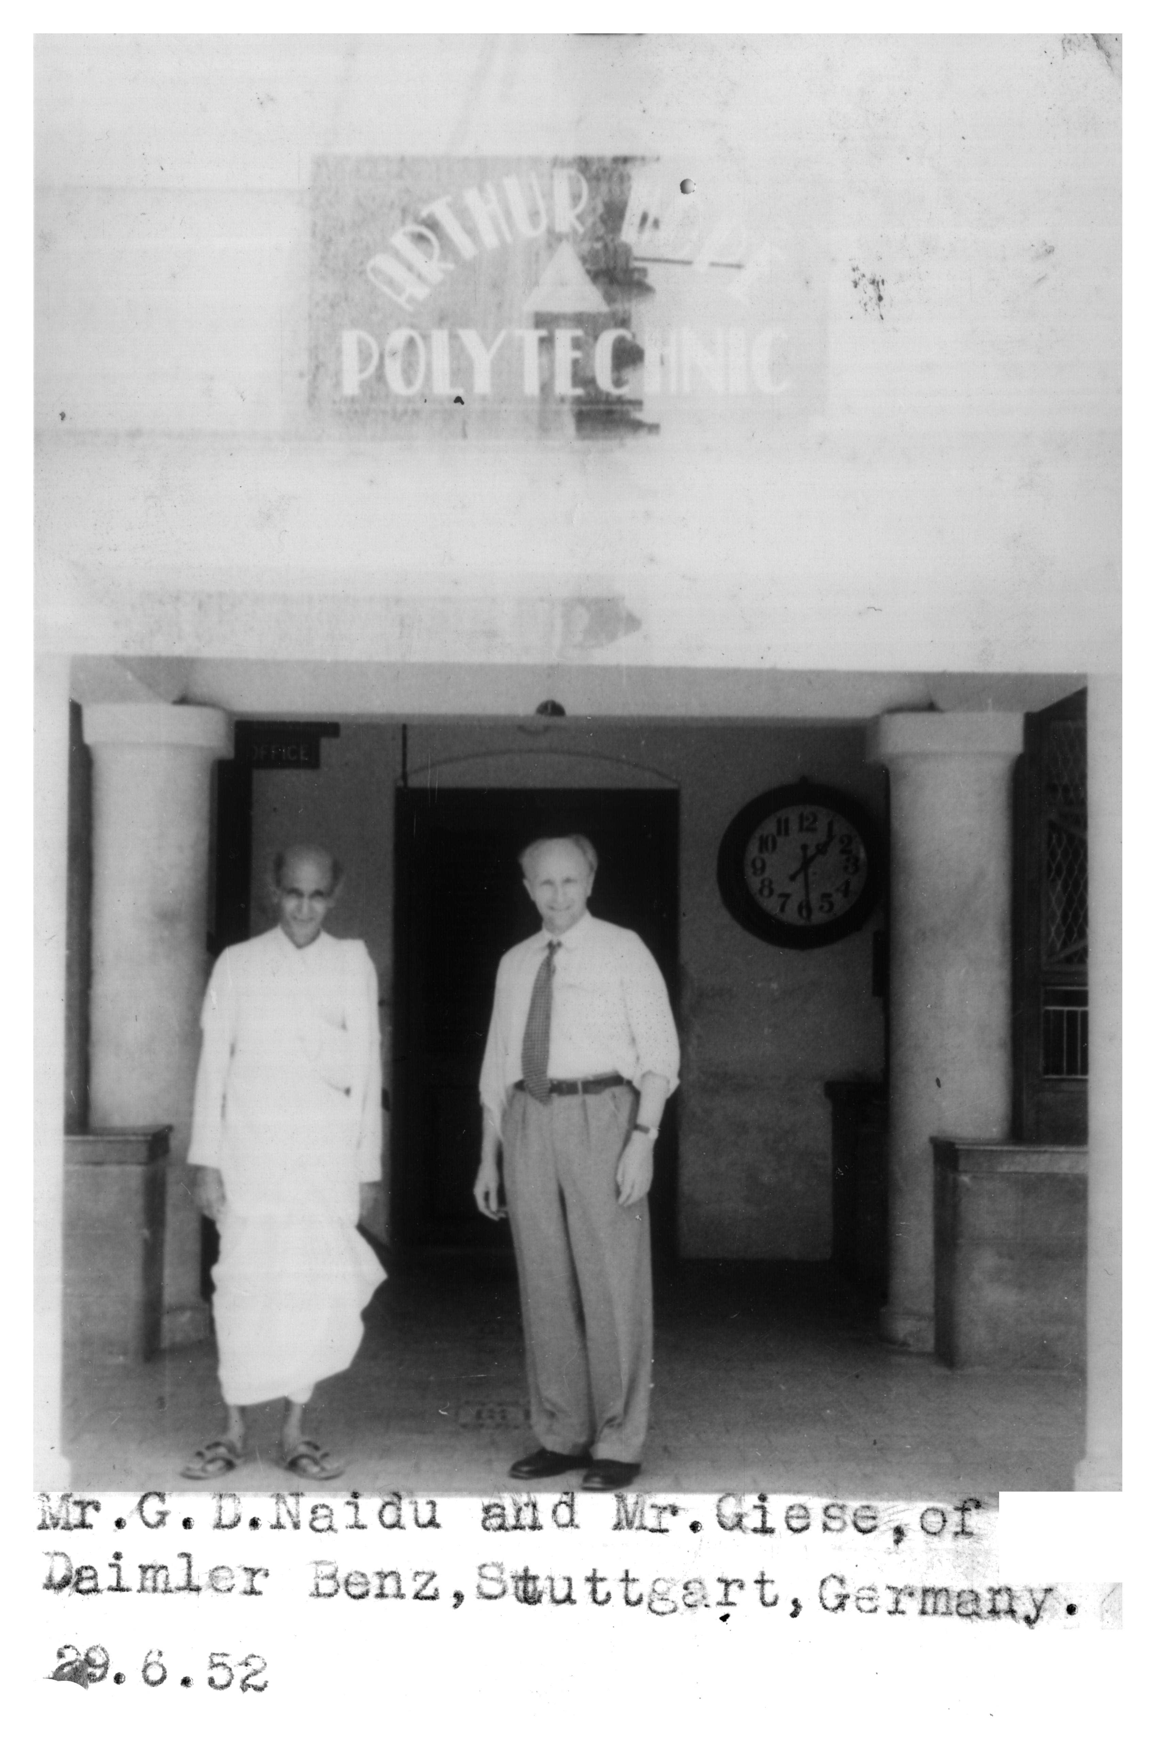
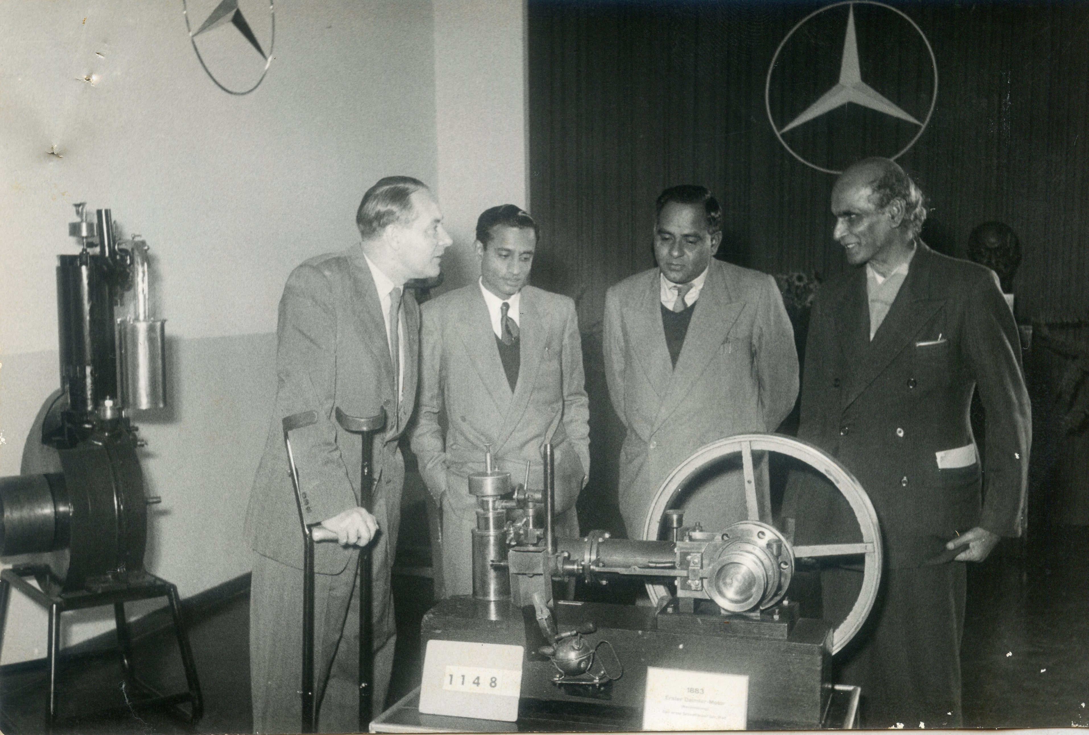
Caption: The Mercedes Benz Connect

Whether or not the specifics of the Mercedes-Benz collaboration ever amounted to a signed agreement, the broader pattern is unmistakable. The country that built the modern automobile took Naidu seriously enough to consider him a potential partner. The country in which Naidu was born and worked could not bring itself to grant him a licence to manufacture his own car. The asymmetry is the story.
“Stuttgart was ready to come to Coimbatore. New Delhi was not.”
Why This Matters Now
It is tempting to read this story as a lament. It would be a misreading. The Naidu car story is not, finally, a lament. It is a warning.
Three quarters of a century after the licence was refused, the country is once again celebrating the rediscovered virtue of indigenous manufacturing. Slogans have been written. Schemes have been launched. Speeches have been made. The phrase "Make in India" has been printed on banners across the country. And yet the underlying instinct — the bureaucratic instinct to require permission before allowing innovation, to ration capacity, to channel approvals to a small club of incumbents — has not entirely left us. The licence-raj is not gone. It has changed clothes.
The lesson of the Naidu car is not that 1952 was uniquely bad. The lesson is that any time the question of an indigenous innovation lands on a government file, the gate-keeper at that file holds in their hand the power to delay a country by a generation. They almost certainly do not see it that way. They will be doing their procedural duty, exercising appropriate caution, ensuring orderly development of capacity. And the country will lose another decade by the time they are done.
G.D. Naidu was the sort of inventor that any sensible policy environment would have built itself around. He had a workshop. He had a working prototype. He had a price point. He had a market. He had the temperament to scale. He had — even — the international interest of one of the great names in global automotive engineering. He had every ingredient a young nation could possibly ask for in its first indigenous car manufacturer. The only thing he did not have was the signature on the form.
What Remains
Half a century after Naidu's death, the work of remembering this car is being taken up by an unlikely instrument — a feature film. A film is not policy. It will not, by itself, redress what was lost. But it can do what the textbooks have so far refused to do: put the face of the man, the shape of the car, and the file of the refusal on a screen large enough that a country can no longer look past them.
When you watch the film, watch for the car. When you next pass a Coimbatore showroom and see the latest Indian-built compact on its plinth, watch for the long line of inheritance that runs from that car back to the workshop in 1952. And when the next licence application for the next indigenous innovation lands on a government file somewhere in this country — as it will, today, tomorrow, next week — remember Naidu. Remember the two-thousand-rupee car. Remember the German engineers who were ready to come.
Caption : The Rs 2000 car in 1952 was costing Rs 3000 in 1968

