A FEATURE ARTICLE FROM THE GD NAIDU SERIES — FOR EDITORIAL SYNDICATION
The Razor That Travelled From Coimbatore to Leipzig
How an Indian inventor with no engineering degree built his country’s first electric razor — and a blade that won applause in Germany when his own country was not yet looking.
Word count: ~1,750
• • •
Walk into the GD Naidu Science Museum in Coimbatore today and the first thing you notice is the size of the hall. It is modest. The artefacts inside it are not labelled with the kind of triumphalism that one might expect of a museum dedicated to an industrial pioneer. There are no velvet ropes. The lighting is plain. The showcases are old.
And there, in one of those cases — among the lathe parts and the electric motors and the kerosene-fan housing — sits a small object that has no business being as important as it is. It is a razor. A slim, polished, hand-finished razor with the maker’s name engraved in steel
It is one of the most underrated inventions in the industrial history of independent India.
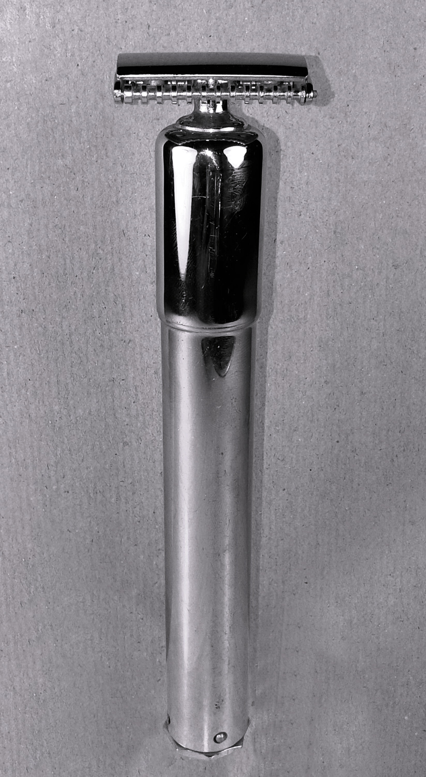
Caption: The original Rasant razor, on display at the GD Naidu Science Museum, Coimbatore.

• • •
The Man Before the Razor
Gopalswamy Doraiswamy Naidu — G.D. Naidu, as the country eventually learned to call him — was born in 1893 in the village of Kalangal, a few hours outside what is now Coimbatore. He left school as a boy. The reasons given in the published biographies are kind: he was restless, the system did not suit him, his hands were better than his pen. He went to work, first on a farm, then briefly in a textile mill, then as a bus Owner Driver on a small motor route in the Madras Presidency.
Within a few years, the Driver was the proprietor. By his late twenties, Naidu owned and ran the United Motor Service — one of the earliest organised motor transport networks in South India. The bus business taught him about engines. The engines led him to the lathe. The lathe led him to the workshop. And the workshop, in the late 1920s and early 1930s, became something extraordinary: a one-man laboratory of indigenous engineering, in a Coimbatore that had not yet imagined itself as the manufacturing capital it would become.
Naidu’s instinct, the one that would define his entire career, was simple and unfashionable. He would look at an everyday object that India imported and ask himself a question: "Why not make here?" Why import the textile machinery from Lancashire when we could make a Coimbatore version that ran the same? Why send foreign exchange abroad for an electric motor when a Coimbatore workshop could produce one in 1937, built from Indian parts, in time for an emerging Indian industry to use?
That is the temperament with which he turned his attention, sometime in the late 1930s, to a much smaller object — the safety razor in his own bathroom.
The Problem He Saw
The shaving razor of the 1930s and 1940s was, for most Indian households, an imported luxury. The good ones — Gillette from the United States, Wilkinson Sword from England, Rotbart from Germany — were beyond the reach of the ordinary Indian. The cheap ones were rough, unsafe, and quickly blunt. For a country in which the everyday Indian man shaved at home, often with a borrowed blade, the razor was a small object that exposed a big economic truth. India did not yet make its own.
It was not too small. It was exactly the right size. Because Naidu’s genius was never really about scale. It was about access. He believed, with a kind of quiet conviction, that the everyday objects of Indian life ought to be made in India by Indian hands, sold to Indians at prices Indians could afford. The razor was a perfect test of that belief.
“He believed that the everyday objects of Indian life ought to be made in India by Indian hands, and sold to Indians at prices they could afford.”

Building the Rasant
What emerged from Naidu’s Coimbatore workshop in the years 1935-36 that followed was a razor unlike any that had been made in India before. He called it the Rasant an electrical Razor— a name with a clean, mechanical ring to it, suggestive of speed and precision. The Rasant was thin. It was slim where its competitors were heavy. It was finished by hand. It was assembled by workers Naidu trained himself.
The two engineering achievements at the heart of the Rasant were the blade and the body. The blade (called UMS Blade) is the part of any razor that decides everything — the angle of the cut, the safety of the user, the comfort of the shave. Naidu’s blade was, by the accounts of those who saw it then and the artefacts that survive now, among the thinnest that had been produced in Asia at that time. It was hand-finished to a level of precision that surprised the European visitors who would later examine it. The body, machined in his Coimbatore workshop, was light, balanced and — crucially — manufacturable at scale by workers who did not need a German technical education to assemble it correctly.
A powered shaver designed and manufactured in India, at a time when the very idea of an Indian-made electric shaver was novel. It was the first electric razor of its kind to come out of an Indian workshop. The country that imported its motors, its appliances, its very idea of modernity in personal grooming, had quietly produced one of its own. From Coimbatore.
Caption: Close-up of the Rasant razor blade

The remarkable thing, however, was not just that the Rasant existed. The remarkable thing was that it was good.
• • •
Leipzig, 1936: The Stage on Which Coimbatore Bowed
The Leipzig Trade Fair — the Leipziger Messe — has been one of the great industrial showcases of central Europe for more than eight centuries. By the middle of the twentieth century it was the most important commercial meeting on the European calendar, the hall in which manufacturers from across the continent and beyond presented their finest objects to the most exacting buyers in the world. To exhibit at Leipzig was to be taken seriously. To win at Leipzig was to be admitted into the small society of inventors and industrialists whose work the German engineering tradition considered worth its respect.
It was at Leipzig, in the year 1936, that G.D. Naidu’s Rasant razor and its accompanying blade travelled and were noticed. The exact year, the exact category and the exact citation are the subject of careful archival work currently being conducted with the Leipziger Messe Archive and the Stadtgeschichtliches Museum Leipzig. The Trust’s own internal records, the artefacts that survive in Coimbatore, and the oral history that has lived in Tamil Nadu’s engineering circles for three generations all converge on the same fact: at Leipzig, the UMS Blade was honoured. The blade — slim, precise, hand-finished in Coimbatore — earned a recognition that Indian industry of that era almost never earned abroad.
Picture the moment. The hall is full of buyers and exhibitors from the great manufacturing nations of Europe. The German precision-engineering tradition is on full display in every booth. And up on the stage, or in the citation card that goes with the award, is the name of an inventor from a city most of the audience has never heard of. A small Indian object. A perfectly finished blade. A standing acknowledgement that the inventor from Coimbatore had built something the Germans themselves found worth honouring.
That moment is one of the most quietly significant moments in the industrial history of post-independence India. We do not teach it. We do not put it in textbooks. The man who made it possible received no Bharat Ratna for it, no Padma Vibhushan, no national fanfare. Tamil Nadu remembered. Coimbatore remembered. The country forgot.
“Germany honoured the blade. India honoured the silence.”
Why This Matters — Then and Now
It is tempting to read the Rasant story as a feel-good vignette about a forgotten inventor. That reading misses the point. The Rasant story is, properly read, a story about the choices a country makes when it decides what counts as recognition.
Europe was queueing up to applaud his UMS razor blade. The asymmetry is not a coincidence. It is a pattern. The pattern is that India has, for most of its post-independence history, treated grassroots indigenous engineering with a polite indifference that contrasts painfully with the open enthusiasm of the world’s great manufacturing nations.
The Rasant blade was small. It was, in cost terms, almost trivially affordable. It was the very embodiment of the kind of frugal, mass-manufacturable, locally-sourced product that the policy makers of contemporary India now describe as the future of Indian manufacturing. And it was made in Coimbatore, by an inventor who never received an engineering degree. Ninety one years later, the country is still searching for the formula that this man already had. He did not call it "self-reliance." He did not give it a slogan. He just got out of bed every morning, walked to his workshop, and made another one.
Coimbatore today is one of India’s most quietly self-reliant industrial clusters. Its textile MSMEs feed the world. Its small-component manufacturers anchor the entire Indian automotive supply chain. Its engineering colleges produce a steady supply of skilled hands. None of this is an accident. It is the long shadow of G.D. Naidu’s temperament — the belief that an Indian workshop is as good as a Bavarian one if you respect it the same way.
The Rasant Today — A Visit to the Exhibition
You can still see it. The original Rasant razor sits in its case at the GD Naidu Science Museum in Coimbatore, surrounded by the other small wonders Naidu produced — the electric motor of 1937, the kerosene-operated fan, the UMS Radio, the vote-recording machine, the textile equipment. The Exhibition has been open to the public since 1960s. It is one of the most unusual industrial museums in the country: part biographical archive, part artefact display, part working tribute to a kind of engineering taste that an entire country forgot to honour while the man was alive.
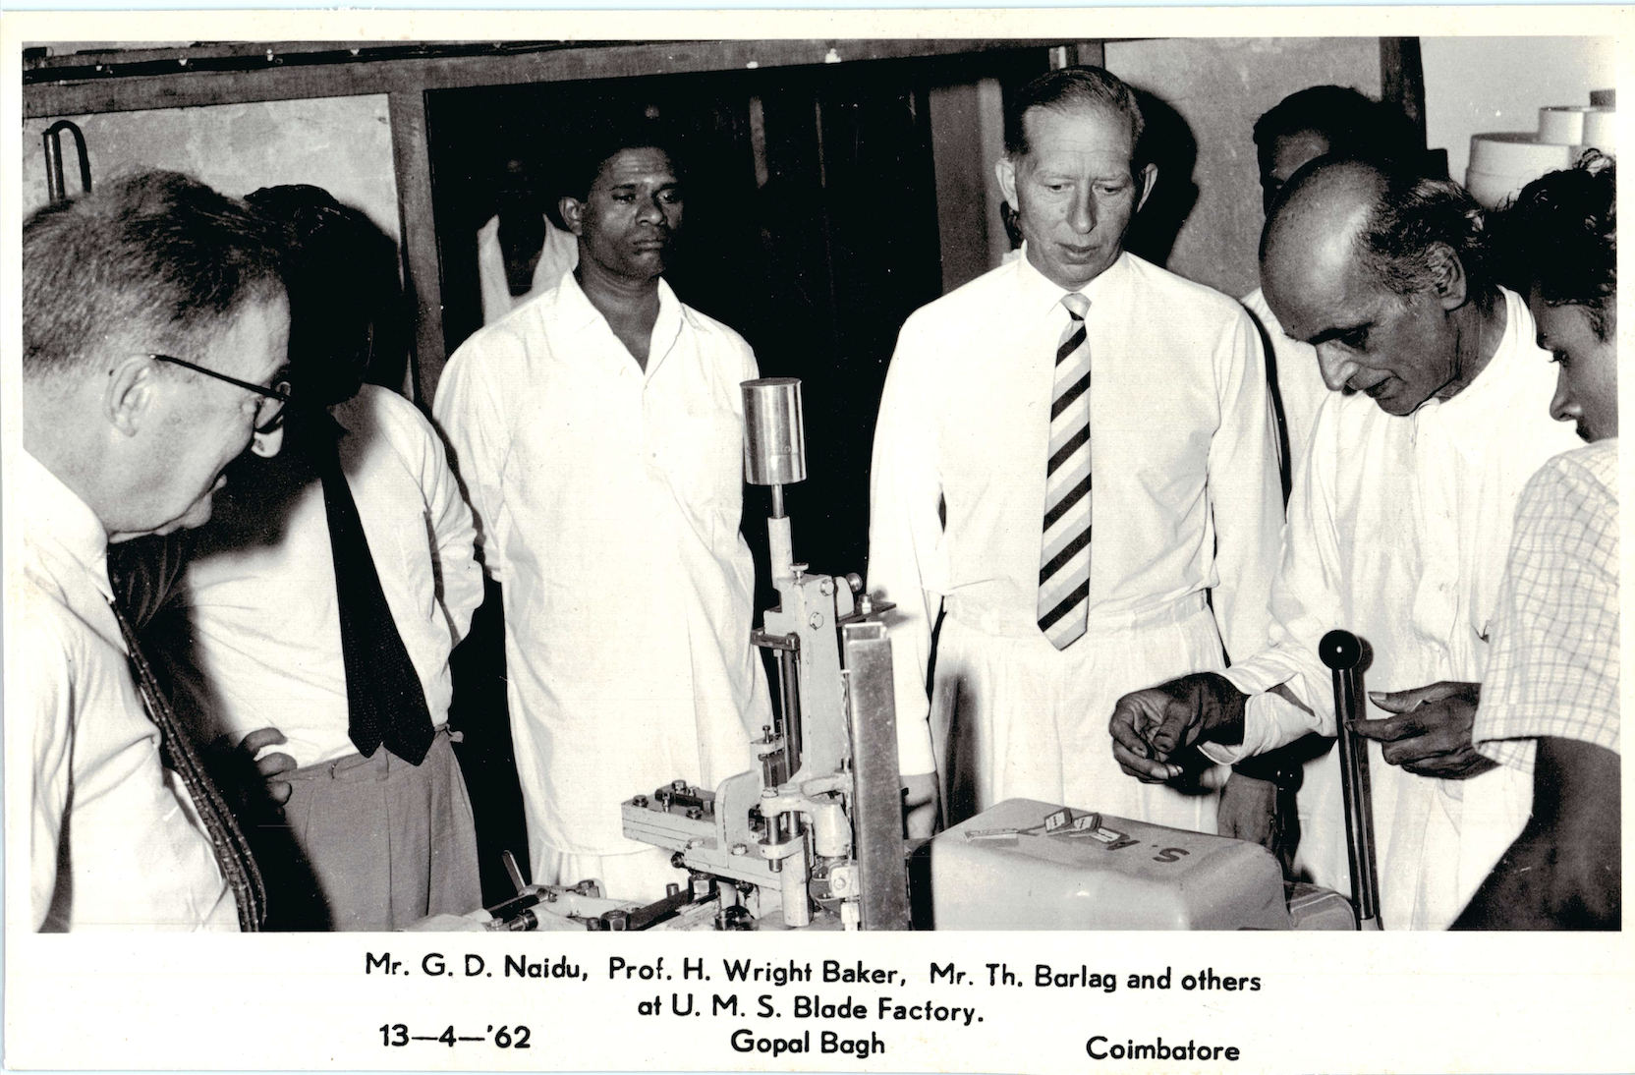
Caption: General view of the GD Naidu Science Museum, Coimbatore — display cases showing the Rasant and surrounding artefacts.

Visit the Science Museum and stand in front of the showcase that holds the Rasant. Look at the UMS blade. It is small. It is thin. It is finished as carefully as any object of the same era from any country in the world. And it sits there, quietly, waiting for a generation of Indian engineers and designers to walk past and notice that the thing they are now being told to build — frugal, indigenous, world-class — was built by a man Ninety one years ago.
• • •
The film about G.D. Naidu, to be released in July, will tell parts of this story. The microsite that accompanies the film will tell more. But the most important act of remembering will not happen on a screen. It will happen the next time someone in Tamil Nadu picks up a electric razor — any electric razor — and pauses, just for a moment, to recall that this small object was once made by hand in Coimbatore, and was once carried across the sea to Leipzig, where it earned the applause of a country that had not yet learned its inventor’s name.
Germany remembered. India is still catching up.

