A FEATURE ARTICLE FROM THE GD NAIDU SERIES — FOR EDITORIAL SYNDICATION
The Workshop That Hosted a Nation
A Nobel laureate. The architect of modern Mysore. The principal author of the Indian Constitution. Two Prime Ministers’ worth of senior politicians. They did not summon G.D. Naidu to their offices. They came to his workshop. This is what each of them saw.
Word count: ~2,100
• • •
There is an old book kept in the offices of the GD Naidu Charities in Coimbatore. It is the visitors’ book of the workshop and the Industrial Exhibition that G.D. Naidu founded and ran. Its pages are not new. The signatures are not all famous. Many of them are by schoolchildren, by curious local engineers, by Coimbatore neighbours who walked in to see what was being built next door.
But here and there, between the unfamiliar names, are signatures and dates that make the reader stop. A Nobel Prize-winning physicist. The man whose birthday this country still observes as Engineer's Day. The principal architect of the Indian Constitution. A Prime Minister. A President. Two Chief Ministers of Tamil Nadu. The founder of the Dravida Munnetra Kazhagam. Senior governors, ambassadors, industrialists, scholars.
The visitors' book of a workshop in Coimbatore reads, in places, like the register of a small but discerning national assembly. The man at the centre of it was a school dropout with grease under his fingernails. He did not travel to be received. They travelled to receive him in his own city.
This is the story of who came, what they saw, and why each of them came back convinced they had been in the presence of something they had not expected to find — a Tamil mechanic who had become, by some quiet alchemy of his own, the conscience of indigenous Indian engineering.
.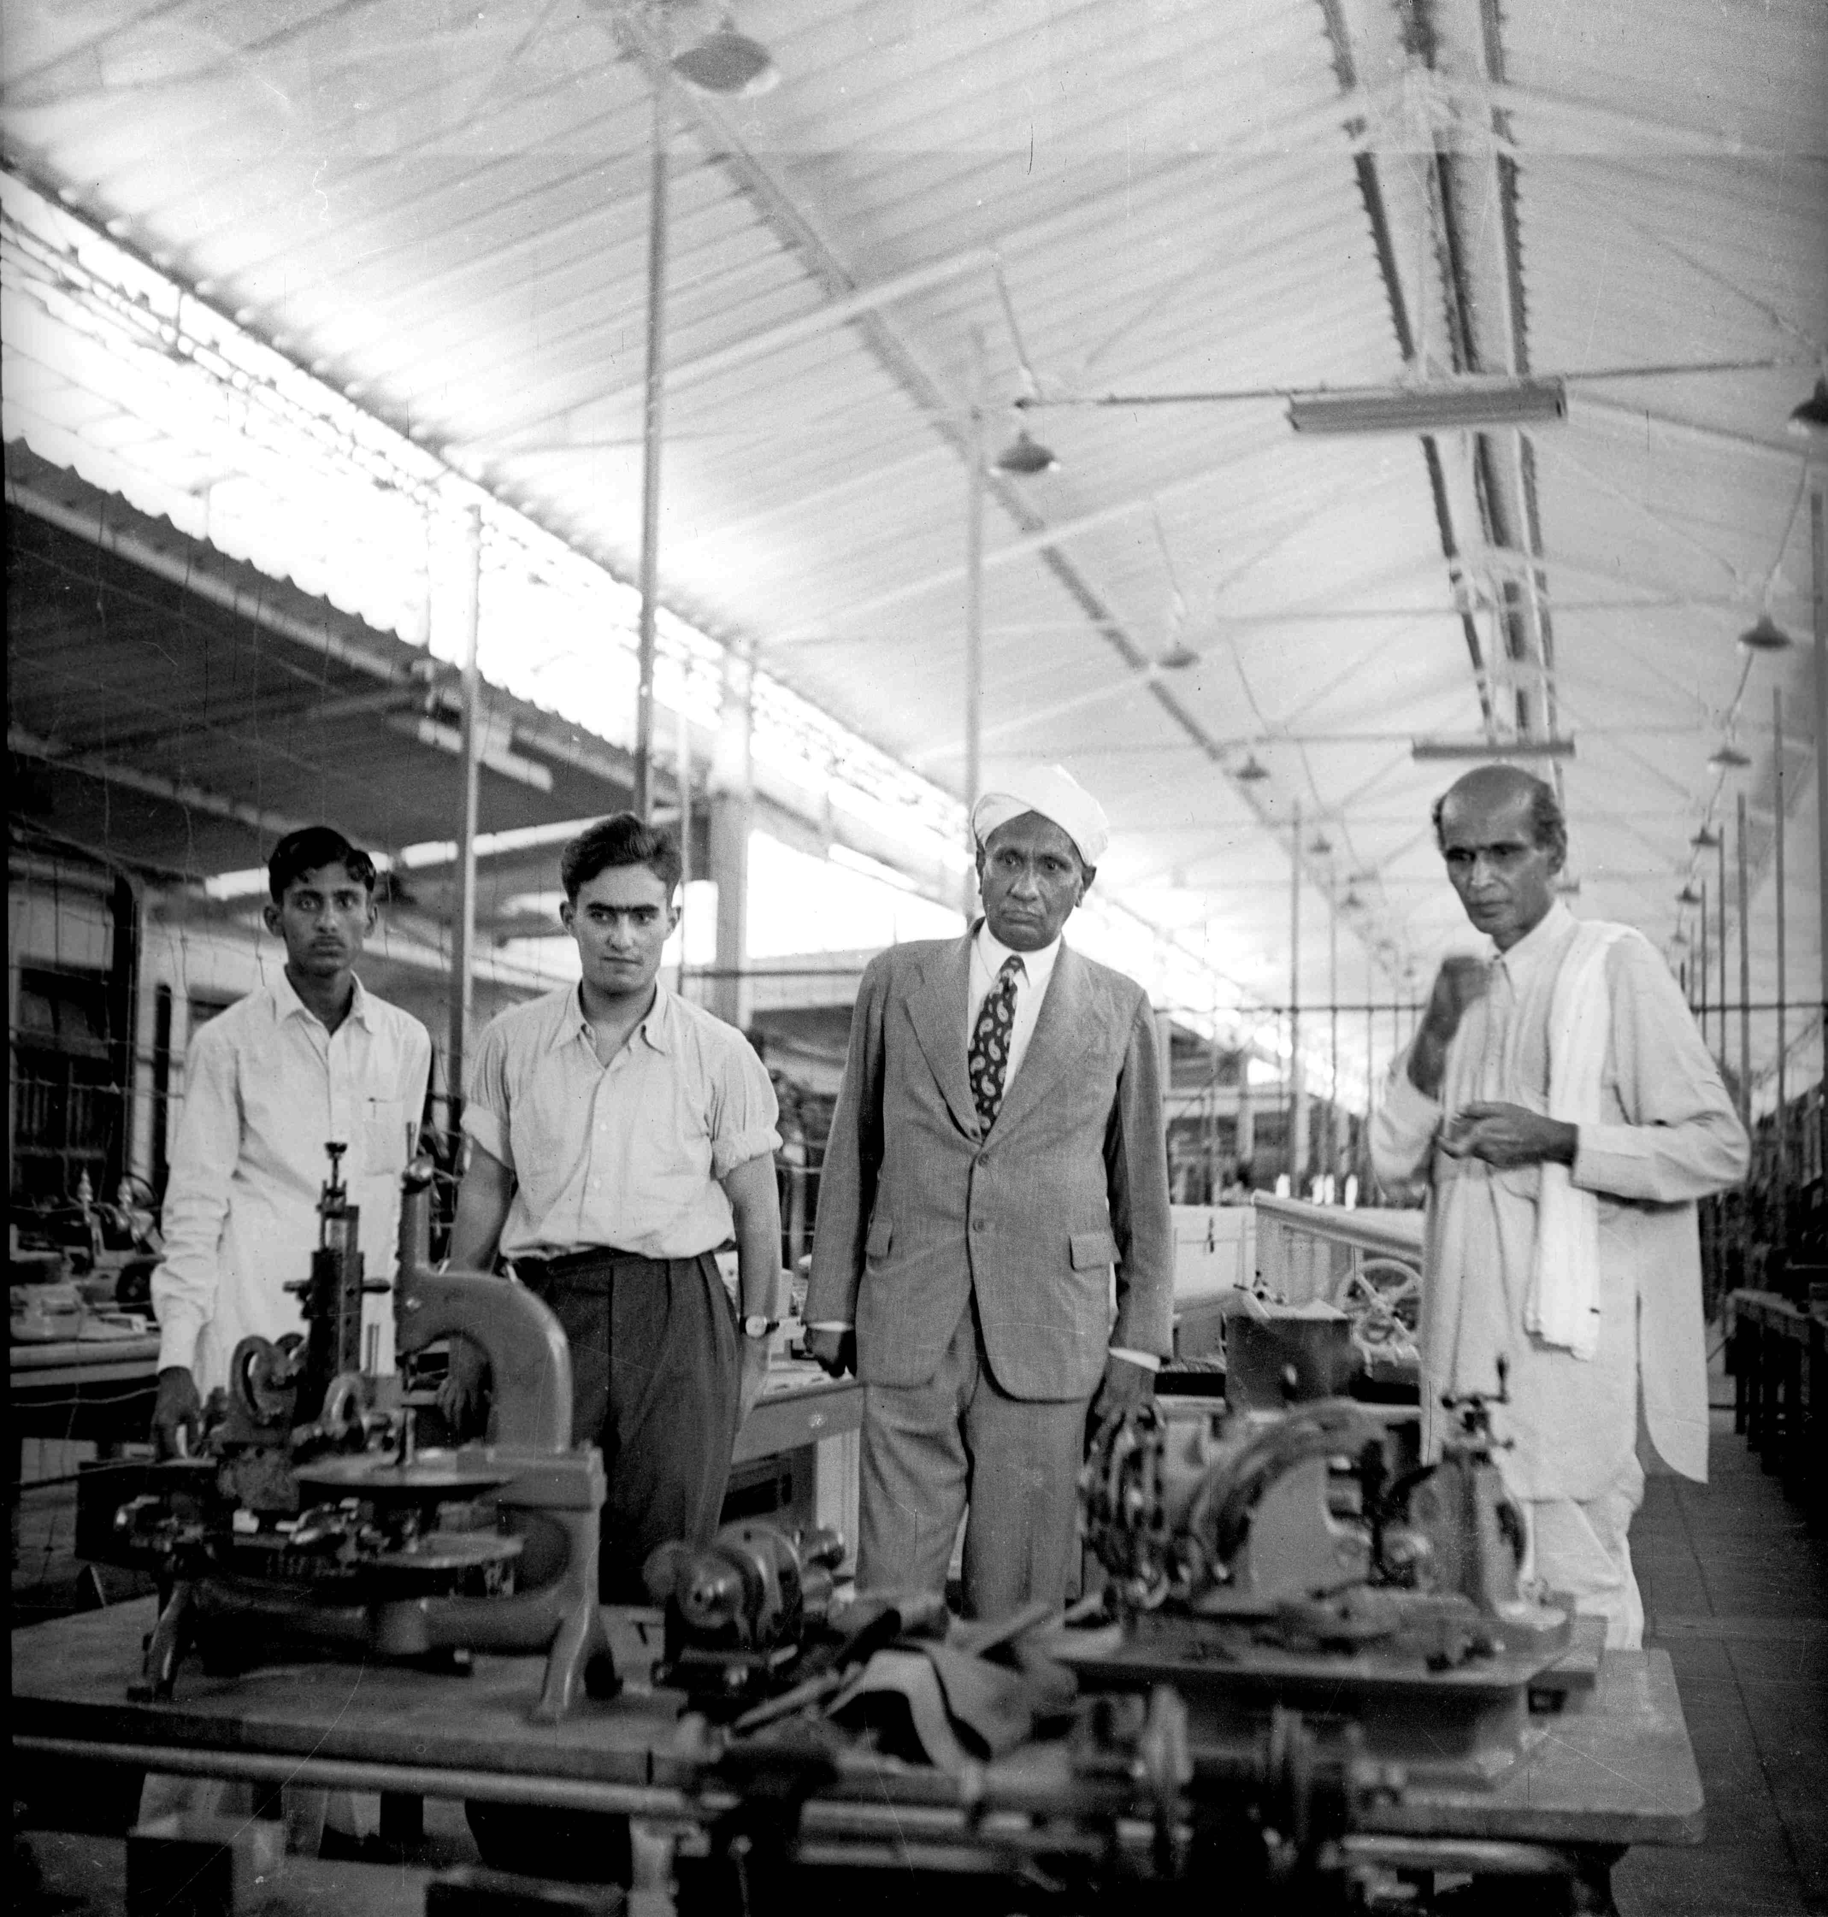
Caption:

• • •
Through the Eyes of Science
Sir C.V. Raman
India's first scientific Nobel laureate is said to have visited G.D. Naidu at his farm-workshop in Coimbatore. The visit was no idle tourist call. Sir C.V. Raman, the discoverer of the Raman effect and the 1930 Nobel Laureate in Physics, was Director of the Indian Institute of Science in Bangalore from 1933 to 1937, and a man whose hours were not casually given. When he travelled, he travelled for a reason.
What he saw in Naidu has been described in Tamil engineering circles for three generations. He saw a man without formal training who had nevertheless arrived at the same quiet, exact, observational discipline that the best Indian scientists of the era took years of formal study to acquire. Raman, who had a famous impatience with affectation and a famous love for craftsmanship, recognised in Naidu the genuine article — an inventor who built things, not just ideas about things.
It is in this spirit that the phrase attributed to Raman about Naidu has lived in the country's memory. Raman is said to have described G.D. Naidu as "a man in a million." Whether the words were first set down in a letter, recorded in a speech, or quoted by a biographer who heard them from Raman himself in a conversation, is the subject of careful research currently being conducted with the Raman Research Institute and primary biographical archives. The exact provenance will be published on the campaign's primary-source dossier as soon as verification is complete. What is not in dispute is the warmth and seriousness of Raman's regard for Naidu — a regard so unusual, coming from Raman, that the phrase has survived seven decades in Tamil engineering memory while almost nothing else of Raman's casual conversation has.
“A man in a million.”
— Attributed to Sir C.V. Raman, Nobel Laureate in Physics, 1930
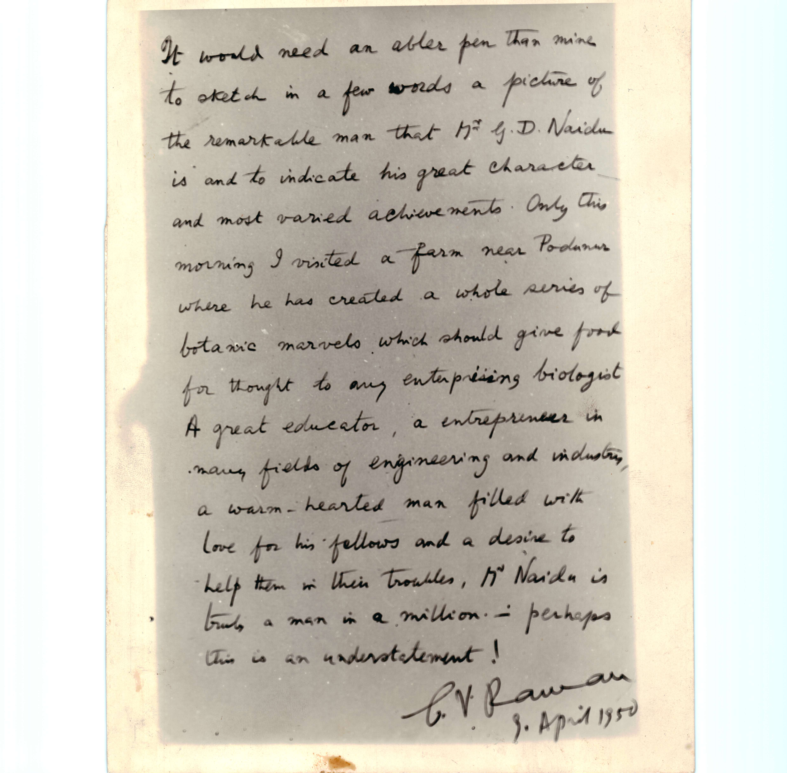
Sir M. Visvesvaraya
If Raman saw a fellow craftsman, Sir M. Visvesvaraya saw a fellow engineer. The two men shared a temperament — precise, frugal, unromantic about work, impatient with anything that did not move forward. Visvesvaraya, the architect of the Krishnarajasagara dam, Diwan of Mysore, recipient of the Bharat Ratna and the man whose birthday on 15 September the country still observes as Engineer's Day, was already a national figure when Naidu was still consolidating his reputation in Coimbatore. The contact between them was, by the records held at the GD Naidu Charities and referenced in published biographies of both men, sustained and substantive.
Visvesvaraya recognised in Naidu the same thing he had recognised in his own engineering staff in Mysore — the habit of building. Visvesvaraya did not respect blueprints; he respected built infrastructure. Dams, irrigation channels, factories, working machinery. Naidu produced built things — motors, fans, razors, radios, cars — and produced them with a precision and a thrift that mirrored Visvesvaraya's own. The visits, correspondence and acknowledgements between the two are part of the documentary record of the GD Naidu Charities and the Visvesvaraya National Memorial Trust. The campaign team is currently coordinating with both institutions to publish primary-source images of this correspondence on the microsite.
It is no small thing for the man who built modern Mysore to count an indigenous Coimbatore inventor among his peers. He did. And he said so.
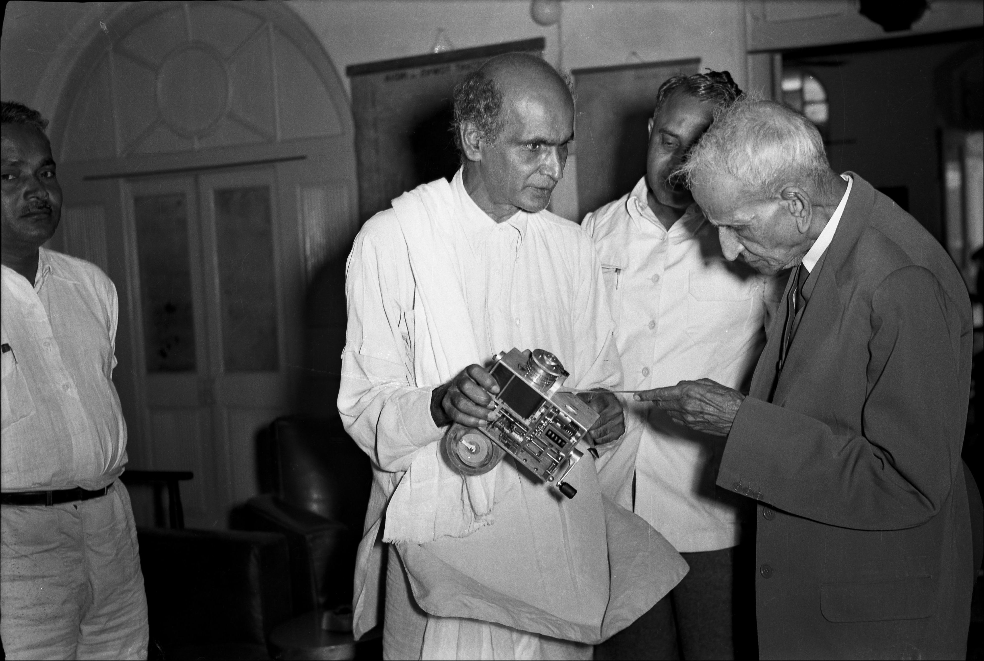

Through the Eyes of the Constitution
Dr. B.R. Ambedkar
Of all the names in the workshop's visitors' record, the one that takes the breath away is the one fewest people in the country know about: Dr. B.R. Ambedkar.
Ambedkar was the principal architect of the Indian Constitution, the towering intellectual conscience of twentieth-century India, the most powerful voice the country produced for the dignity of its most oppressed people. He was also a man who travelled hard, listened closely and wrote unsentimentally. When Ambedkar walked into a place, it was because he wanted to see what was there, not to be photographed having been.
There is, in the documentary record now being assembled by the campaign team in coordination with the GD Naidu Charities, an account that Dr. Ambedkar visited G.D. Naidu in Coimbatore and subsequently wrote a letter of admiration in which he recognised Naidu as a genuine engineering and industrial genius — and, with Ambedkar's characteristic directness about the social geography of Indian achievement, recognised him specifically as a non-Brahmin genius emerging from the Indian working public. The letter, if confirmed as authenticated, would be one of the most significant single documents in the history of indigenous engineering in this country: an unambiguous endorsement of Naidu, on Ambedkar's letterhead, in Ambedkar's hand.

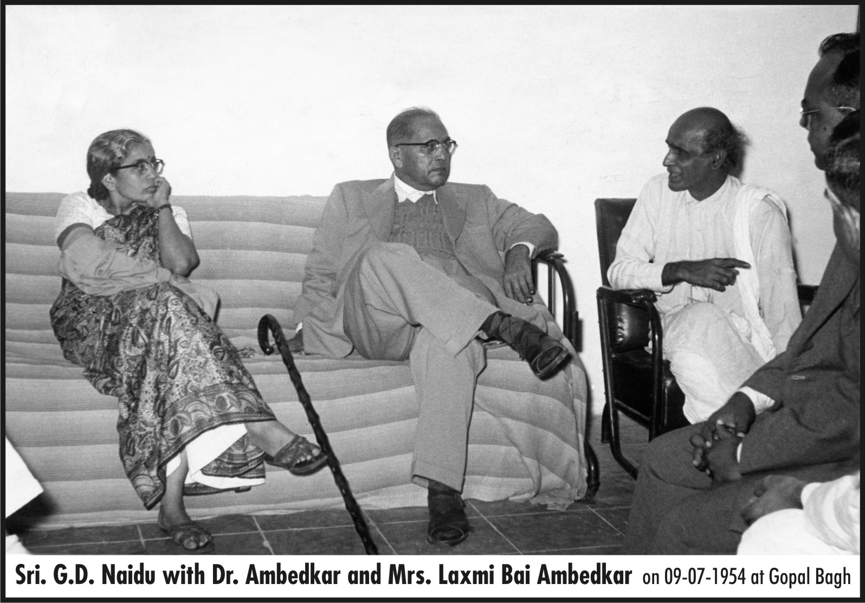
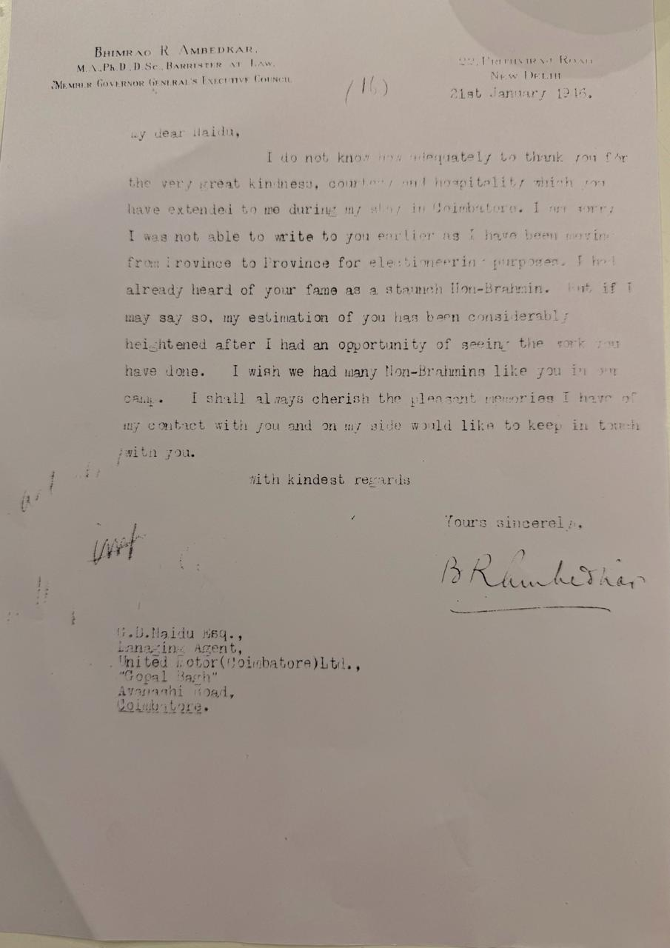

What is striking about the Ambedkar engagement, even before the documentary verification is complete, is what it tells us about the company Naidu kept. Ambedkar did not casually praise. He did not casually visit. He had a precise eye for whether a person's public reputation matched the substance of their work. If Ambedkar took Naidu seriously, it was because Naidu deserved to be taken seriously. The visit and the letter, when authenticated, will not change who Naidu was. They will confirm that the most exacting moral and intellectual judge in twentieth-century India had already confirmed it.
“When Ambedkar walked into a place, it was because he wanted to see what was there.”
Through the Eyes of Political India
K. Kamaraj
K. Kamaraj — the three-time Chief Minister of Madras State, the kingmaker of Indian Congress politics in the 1960s, the man who would later draft the famous Kamaraj Plan that transformed Indian education by retiring senior Congress leaders from government to the party organisation — was a known visitor to Naidu's establishment and a steady acknowledger of his work. The connection was, in its way, predictable. Both men were Tamil. Both had risen from modest circumstances. Both held an instinctive respect for the ordinary working Indian. And both, in different domains, were occupied with the same question — how to put the levers of a modern country into the hands of the people who had until recently been kept away from them.
Kamaraj looked at Naidu and saw the educational policy he himself was trying to build, embodied in a man. Here was a Tamil engineer who had taught himself, employed thousands, built indigenous products, and refused to defer to imported expertise. If Kamaraj could persuade every district in Tamil Nadu to produce a fraction of what Naidu had produced, the state would not need anyone's permission to enter the modern world. Kamaraj knew it. He visited. He acknowledged. He came back.
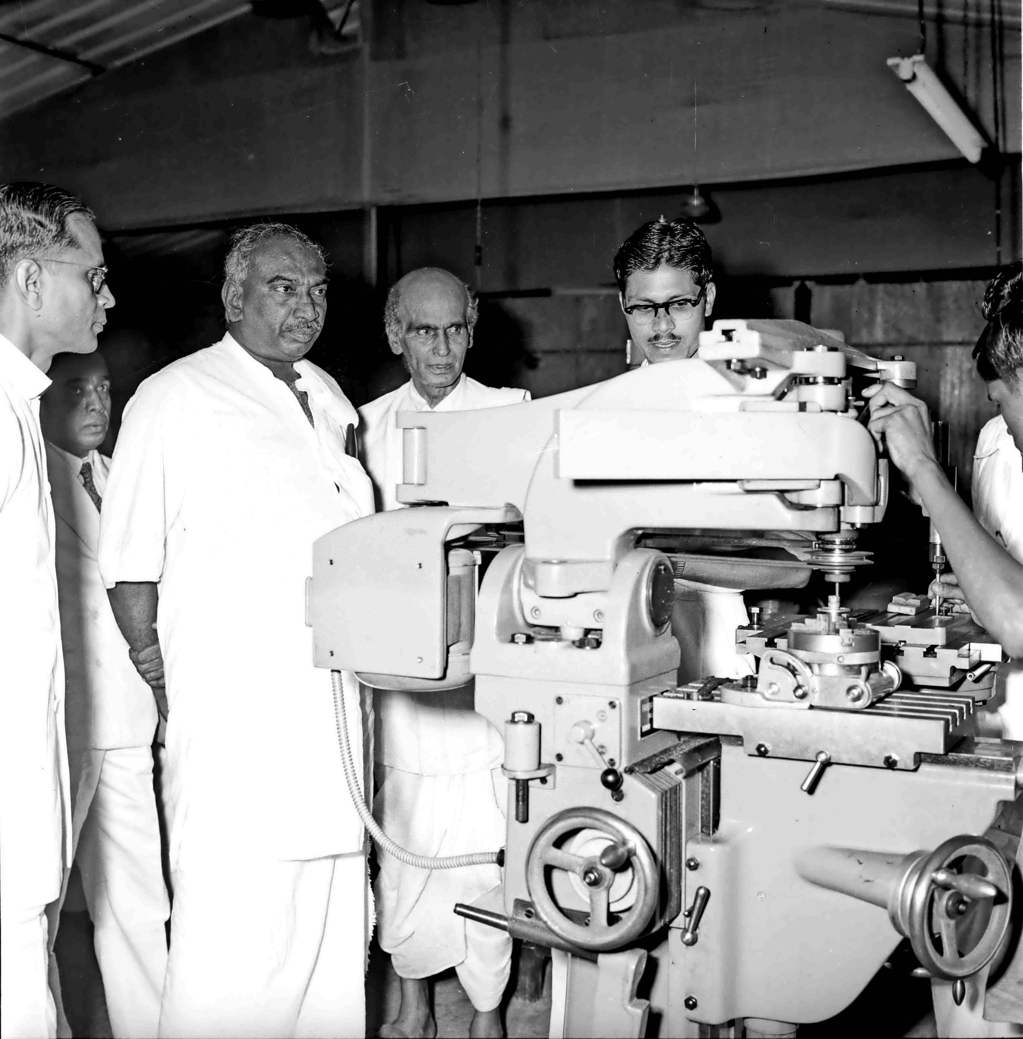
C.N. Annadurai
Where Kamaraj saw policy, C.N. Annadurai — the founder of the Dravida Munnetra Kazhagam and, briefly, the Chief Minister of Tamil Nadu before his death in 1969 — saw cultural assertion. Annadurai's entire political life had been about reclaiming Tamil pride from the long shadows of colonial deference and Brahminical hierarchy. He had argued for the dignity of Tamil language, Tamil literature, Tamil cinema and Tamil identity in a country that had not yet learned to treat them as equal. When he looked at G.D. Naidu, he saw the same proposition embodied in steel and lathes — a Tamil mechanic whose work the world had honoured before India had condescended to notice.
Annadurai recognised in Naidu a Tamil engineering conscience to set alongside the Tamil literary and political ones he was himself helping to build. The visits and acknowledgements between the DMK leadership and the GD Naidu establishment are part of the Trust's archival record and were a quiet, sustained relationship across the political decades.

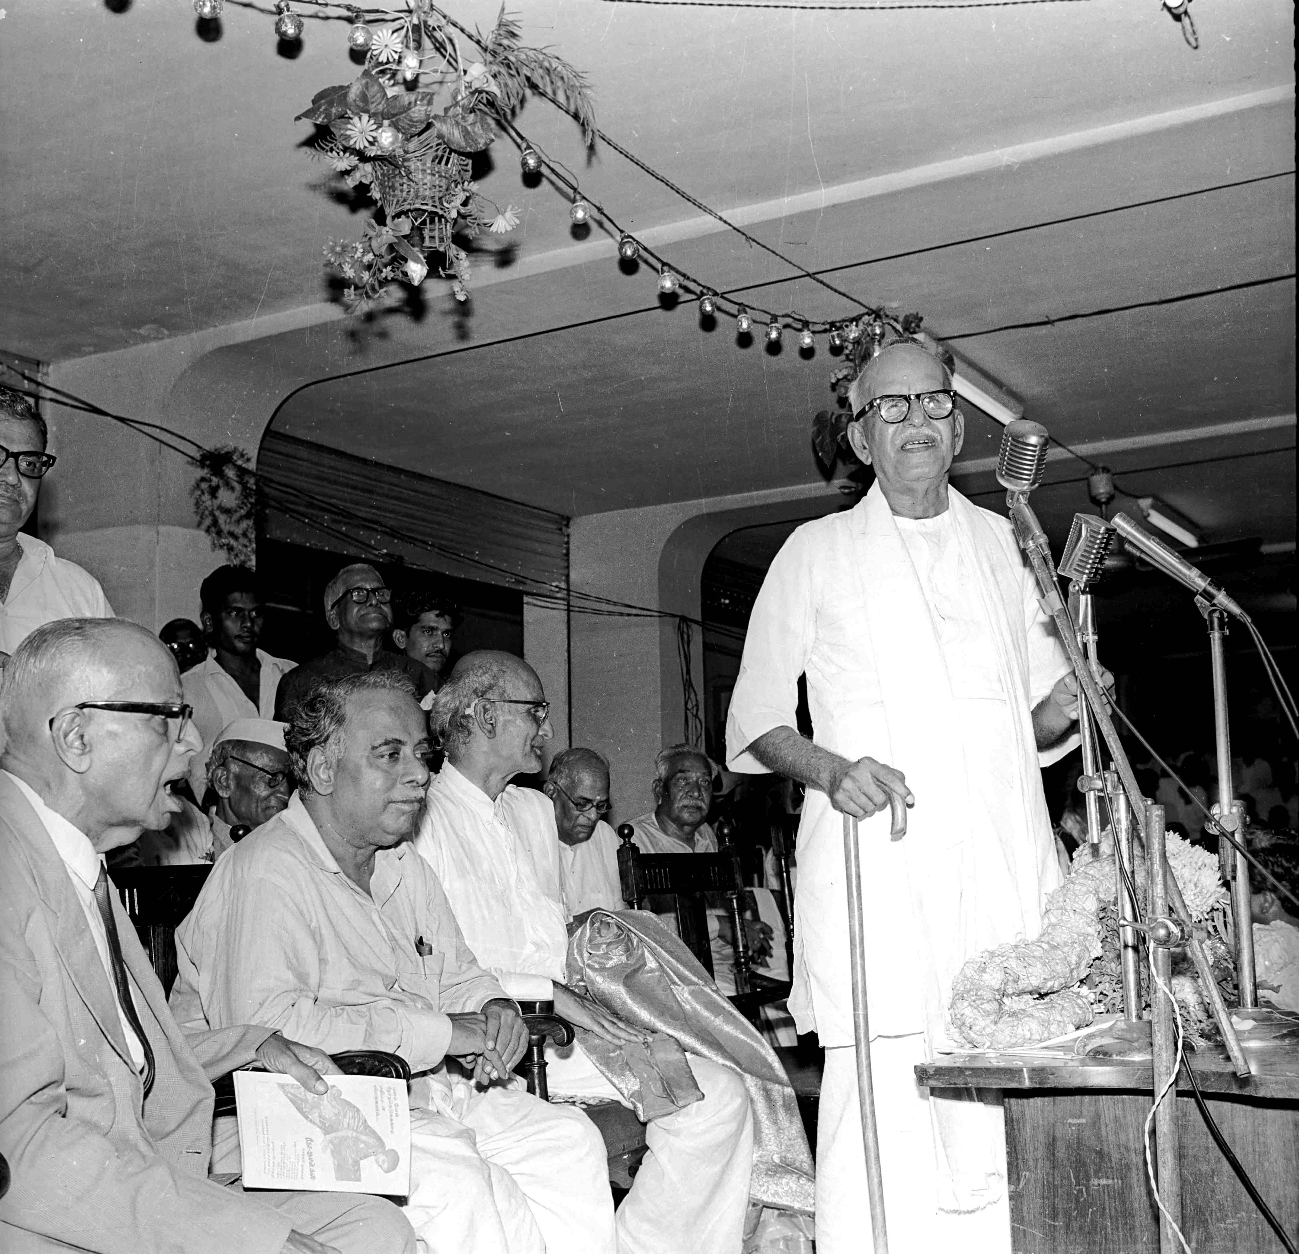
K. Kamaraj’s Plan and Annadurai’s Vision — together
There is something poignant in the fact that two Tamil leaders who disagreed with each other on almost everything else — Kamaraj the Congressman, Annadurai the Dravidian — agreed on G.D. Naidu. They saw him from different sides. They both came to the same conclusion: that whatever they were each trying to build in Tamil Nadu, Naidu was already building it without any of them.

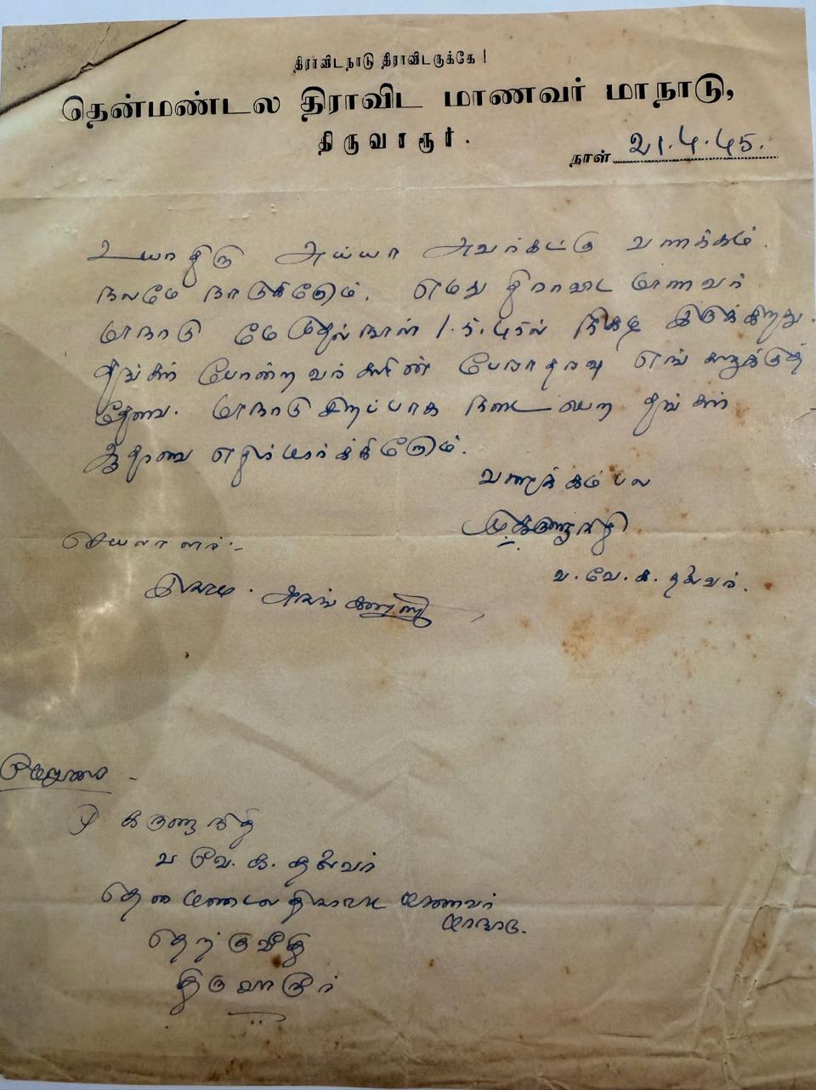
V.V. Giri
V.V. Giri, the fourth President of India from 1969 to 1974, was a former trade union leader, a former Governor and a man whose entire career had been built on the dignity of Indian labour. He spent significant portions of his life in southern India and had a deep regard for the indigenous industrial tradition that had grown up in Tamil Nadu in the post-independence decades. His acknowledgement of Naidu, sustained over years and documented in the Trust's records, was the acknowledgement of a labour leader for an industrialist who had treated his workers with the same dignity that Giri had spent his career insisting on. It was not an alliance of convenience. It was an alliance of values.

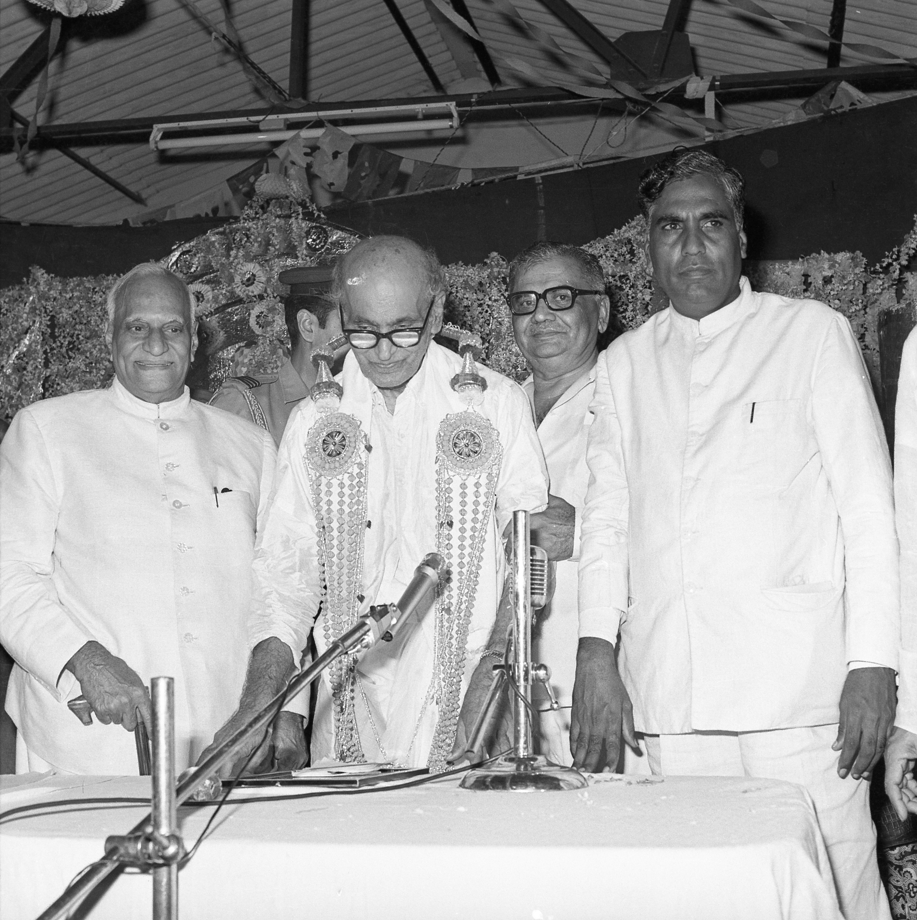
Indira Gandhi
Indira Gandhi met G.D. Naidu in the manner that a Prime Minister of India eventually meets every figure of his stature — through the steady accumulation of acknowledgement, citation and trust archive. She had inherited a country whose industrial licensing regime had refused her a generation of indigenous Naidus. By the time her own premiership turned toward the difficult work of recalibrating that regime, the Naidu name was one she encountered in the briefing notes of more than one ministry. The interactions between her office and the Naidu establishment are part of the documented public record of late-twentieth-century Tamil industrial history.
It is difficult to know how she read him. Indira Gandhi was not given to verbal acknowledgement of regional industrial figures. But the persistence of contact, the awarding by the Government of India of the Padma Shri in 1967 during the term of her father's successor, the steady acknowledgement of his work in the press through her premiership — these are the traces. A Prime Minister who notices is, in the end, a Prime Minister who has noticed.

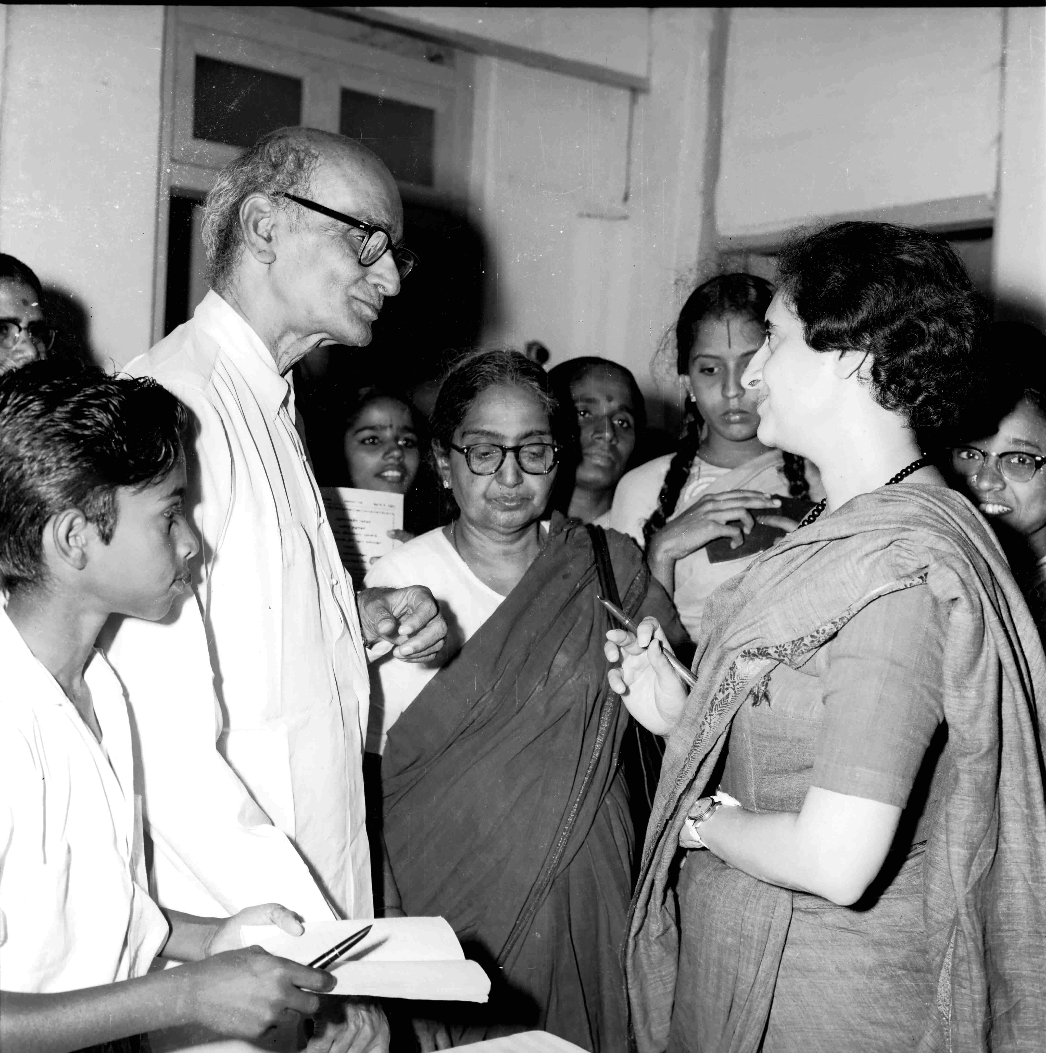
What It Means That They All Came
It is tempting to read this catalogue of names as a list of celebrity acknowledgements — the visitors' book as a kind of national autograph collection. That reading misses the point. The point is what it took to get every one of these people to travel to a workshop in Coimbatore in the first place.
Raman did not visit small-town inventors. Visvesvaraya did not casually take an interest in private workshops. Ambedkar did not write letters of admiration to people who did not deserve them. Kamaraj was not a man who flattered. Annadurai was not given to industrial pilgrimage. Giri was a sober man with limited patience for ceremony. Indira Gandhi noticed almost nobody.
All of them came. All of them noticed. All of them stayed in touch. The cumulative weight of their attention is the closest thing G.D. Naidu received, in his lifetime, to the Bharat Ratna the country never officially conferred on him. They gave him the only ratification that does not require a citation: they came to see.
The lesson, three quarters of a century later, is the one this entire series keeps circling back to. India's scientific establishment, India's constitutional conscience, India's political leadership, India's presidential office — all of them recognised G.D. Naidu in their lifetime. The institutions of state, somehow, did not. The state honoured him with one Padma Shri in 1967 and went back to other business. The men and women who actually understood what he had built — the scientists, the engineers, the moral conscience, the political leaders — they understood. They came. They wrote letters. They kept in touch. They knew.
“The state did not honour him. The people who built the state did.”
What Remains
You can still see the visitors' book. You can still walk into the GD Naidu Industrial Exhibition in Coimbatore, where the photographs of dignitaries examining the artefacts hang on the walls, where the visitors' register lies open in a glass case, where the letters and citations and acknowledgements of seven decades sit quietly under steady archive lighting. It is one of the most unusual personal archives in the country.
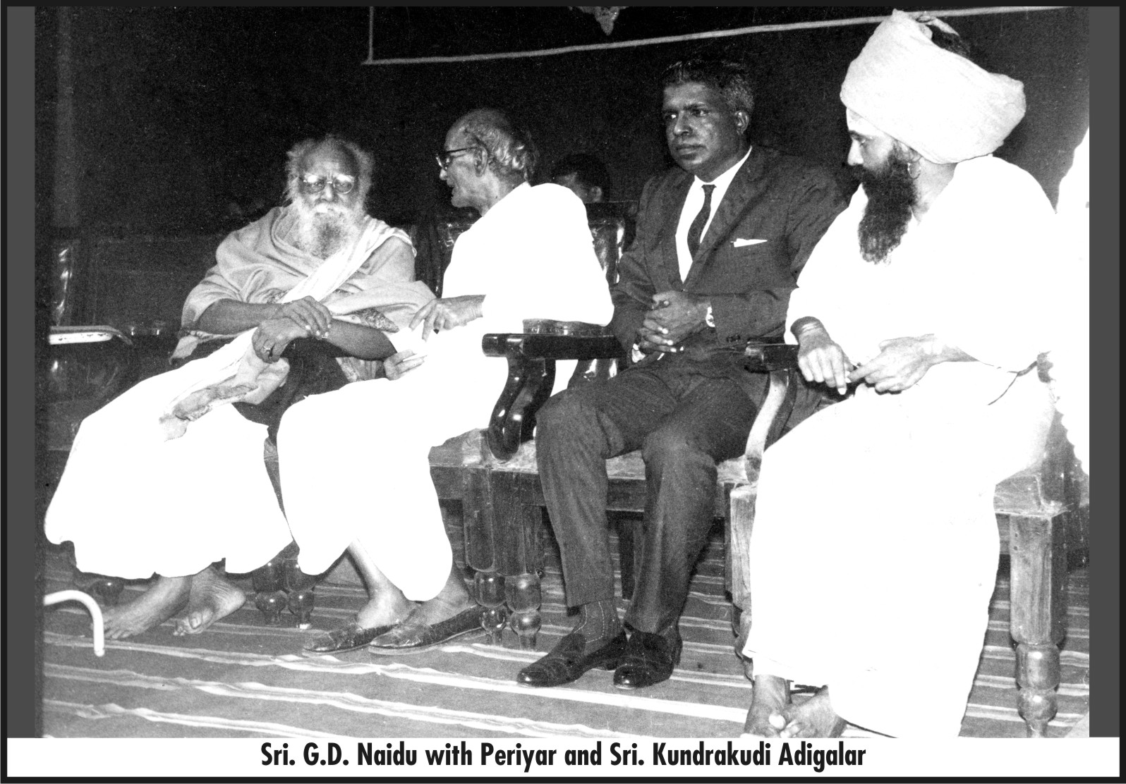

What the film about G.D. Naidu, slated for July release, will do — what no textbook has so far done — is put these visits, these letters, these acknowledgements on a screen large enough that the country can no longer look past them. A Nobel laureate sat with him. The author of the Constitution acknowledged him. The man who built modern Mysore wrote to him. A Prime Minister noticed him. Two Chief Ministers of Tamil Nadu walked into his workshop on different sides of the political aisle and walked out on the same side of an acknowledgement. A President of India counted him a peer.
The country owes its history the courtesy of catching up to its own visitors' book.

